**Contributor name:** Ashwin Guptha

**Book Proposed:** Introduction To Mathematical Statistics By Robert V Hogg,Joseph W. Mckean, Allen T. Craig

**Total Chapters:** 11

**Total Examples:** 475

**Codable Examples:** 84

**Chapter 1: Probability and Distribution**

Example 1.1.1 – Codable

Example 1.1.2 - Non-Codable (Reason: Theoretical example with the purpose of proving a concept)

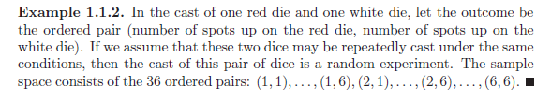

Example 1.1.3 – Non-Codable (Reason: To show a theoretical comparison)

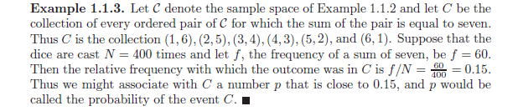

Example 1.2.1 – Non-Codable (Reason: Theoretical example with the purpose of proving a concept)

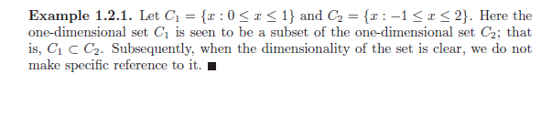

Example 1.2.2 - Non-Codable (Reason: Theoretical example with the purpose of proving a concept)

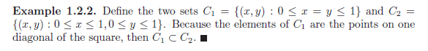

Example 1.2.3 – Codable

Example 1.2.4 - Codable

Example 1.2.5 - Codable

Example 1.2.6 – Codable

Example 1.2.7 - Non-Codable (Reason: Theoretical example with the purpose of proving a concept) 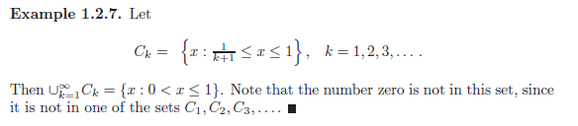

Example 1.2.8 – Codable

Example 1.2.9 – Non-Codable (Reason: Theoretical example with the purpose of proving a concept)



Example 1.2.10 – Codable

Example 1.2.11 - Non-Codable (Reason: Theoretical example with the purpose of proving a concept)

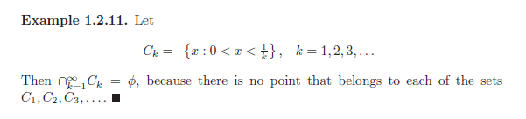

Example 1.2.12 – Codable

Example 1.2.13 – Non-Codable (Reason: Theoretical example with the purpose of proving a concept)

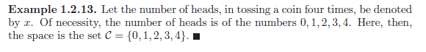

Example 1.2.14 - Non-Codable (Reason: Theoretical example with the purpose of proving a concept)

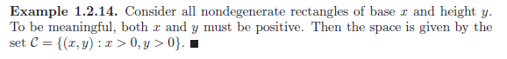

Example 1.2.15 – Codable

Example 1.2.16 – Codable

Example 1.2.17 – Codable

Example 1.2.18 – Codable

Example 1.2.19 - Non-Codable (Reason: Theoretical example with the purpose of proving a concept)

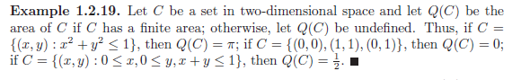

Example 1.2.20 - Non-Codable (Reason: Theoretical example with the purpose of proving a concept)

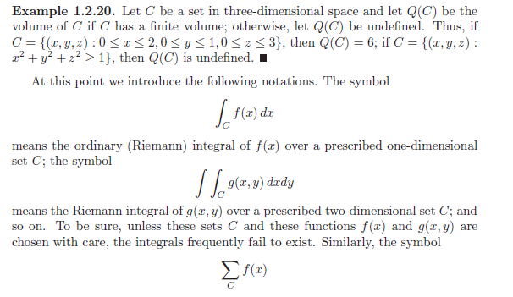 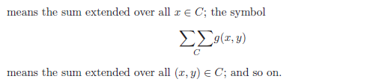

Example 1.2.21 – Codable

Example 1.2.22 - Non-Codable (Reason: No numeric calculations) 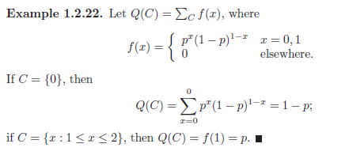

Example 1.2.23 - Non-Codable (Reason: No numeric calculations) 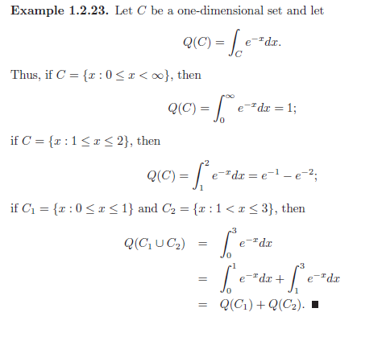

Example 1.2.24 - Non-Codable (Reason: No numeric calculations) 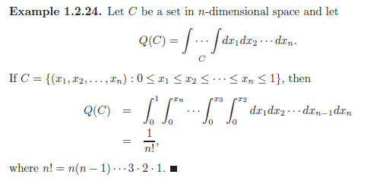

Example 1.3.1 – Codable

Example 1.3.2 – Codable

Example 1.3.3 – Non-Codable (Reason: Theoretical example with the purpose of proving a concept) 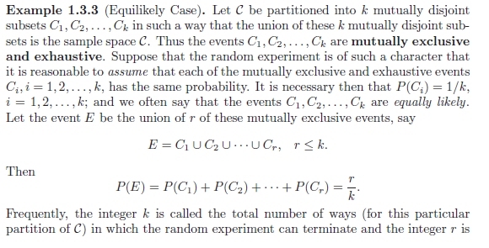 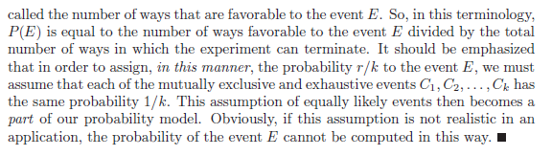

Example 1.3.4 – Codable

Example 1.4.1 – Codable

Example 1.4.2 – Codable

Example 1.4.3 – Codable

Example 1.4.4– Codable

Example 1.4.5 – Codable

Example 1.4.6 – Codable

Example 1.4.7 – Codable

Example 1.4.8 – Codable

Example 1.4.9 – Non-Codable (Reason: Theoretical example with the purpose of proving a concept)

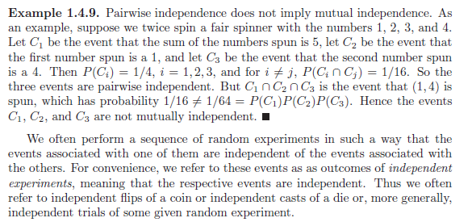

Example 1.4.10 – Codable

Example 1.4.11 – Codable

Example 1.5.1 – Codable

Example 1.5.2 – Codable

Example 1.5.3 – Codable

Example 1.5.4 – Codable

Example 1.5.5 – Codable

Example 1.5.6 – Codable

Example 1.5.7 – Non-Codable (Reason: No numeric calculations)

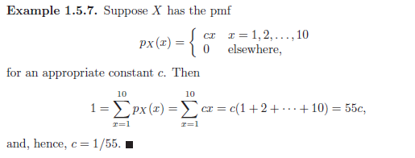

Example 1.5.8 – Codable

Example 1.6.1 – Non-Codable (Reason: No numeric calculations) 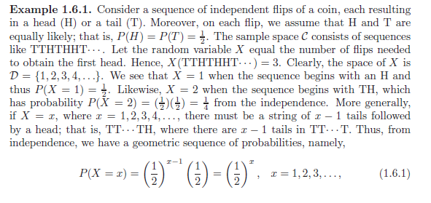

Example 1.6.2 – Codable

Example 1.6.3 – Non-Codable (Reason: No numeric calculations) 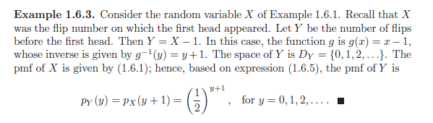

Example 1.6.4 – Non-Codable (Reason: No numeric calculations) 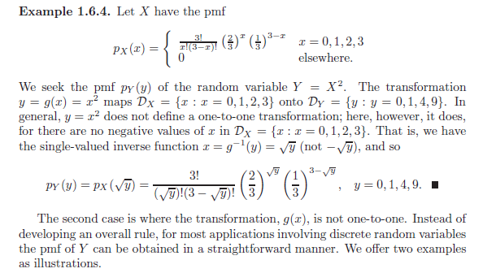

Example 1.7.1 – Codable

Example 1.7.2 – Codable

Example 1.7.3 – Non-Codable (Reason: No numeric calculations) 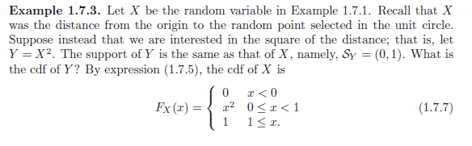

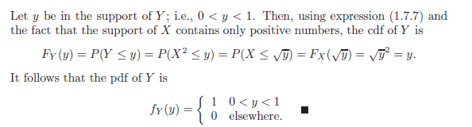

Example 1.7.4 – Non-Codable (Reason: No numeric calculations) 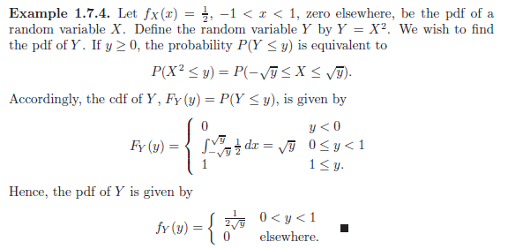

Example 1.7.5 – Non-Codable (Reason: No numeric calculations) 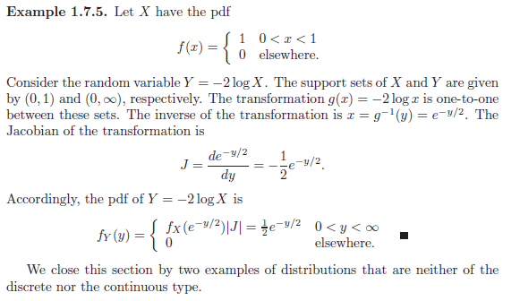

Example 1.7.6 – Codable

Example 1.7.7 – Non-Codable (Reason: No numeric calculations) 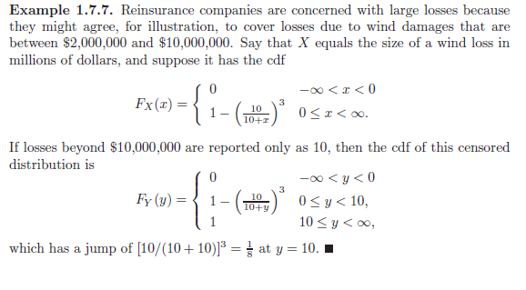

Example 1.8.1 - Non-Codable (Reason: Theoretical example with the purpose of proving a concept) 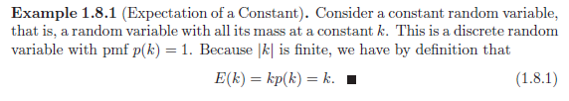

Example 1.8.2 – Codable

Example 1.8.3 – Codable

Example 1.8.4 – Codable

Example 1.8.5 – Codable

Example 1.8.6 – Codable

Example 1.8.7 – Codable

Example 1.9.1 – Codable

Example 1.9.2 - Non-Codable (Reason: Theoretical example, no numeric calculations) 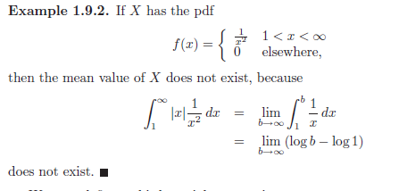

Example 1.9.3 - Non-Codable (Reason: Theoretical example, no numeric calculations) 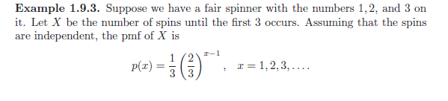 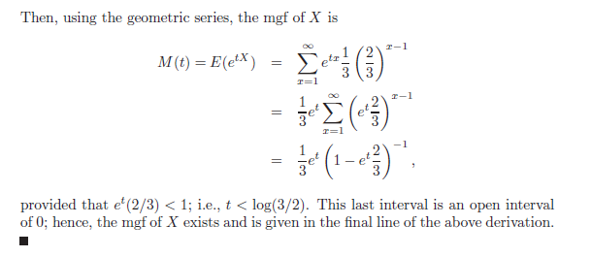

Example 1.9.4 - Non-Codable (Reason: Theoretical example, no numeric calculations) 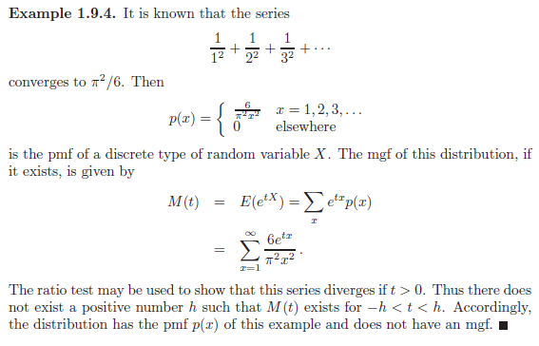

Example 1.9.5 - Non-Codable (Reason: Theoretical example, no numeric calculations) 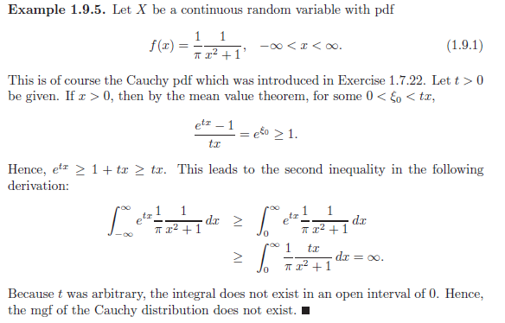

Example 1.9.6 - Non-Codable (Reason: Theoretical example, no numeric calculations) 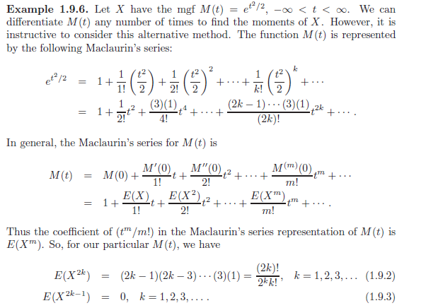

Example 1.10.1 – Codable

Example 1.10.2 - Non-Codable (Reason: Theoretical example with the purpose of proving a concept) 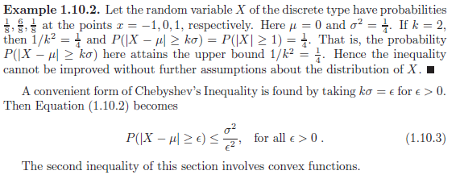

Example 1.10.3 - Non-Codable (Reason: Theoretical example with the purpose of proving a concept) 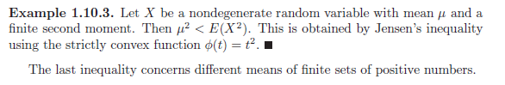

Example 1.10.4 - Non-Codable (Reason: Theoretical example with the purpose of proving a concept) 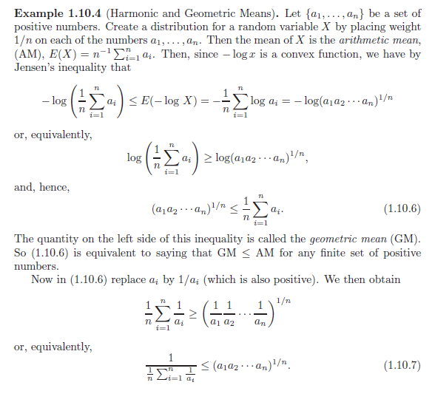

**Chapter 2: Multivariate Distribution**

Example 2.1.1 – Non-Codable (Reason: Theoretical example with the purpose of proving a concept) 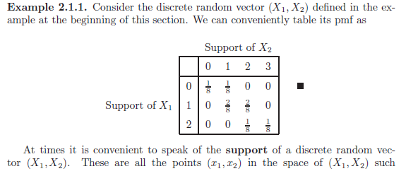 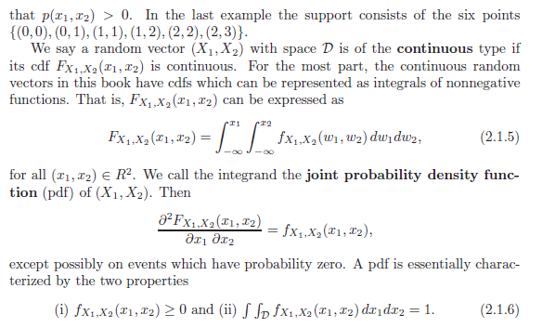

Example 2.1.2 – Codable

Example 2.1.3 – Non-Codable (Reason: Theoretical example with the purpose of proving a concept) 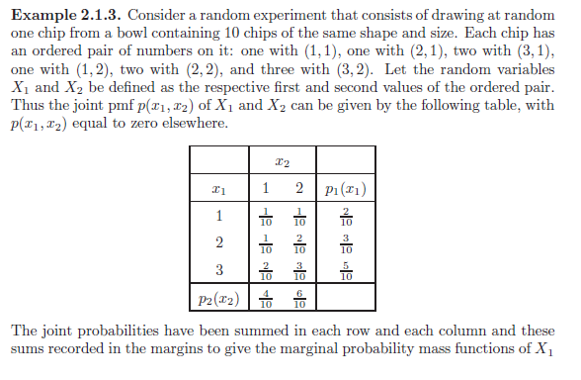

Example 2.1.4 – Codable

Example 2.1.5 – Codable

Example 2.1.6 – Codable

Example 2.1.7 – Non-Codable (Reason: Theoretical example, no numeric calculations) 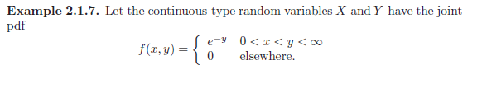 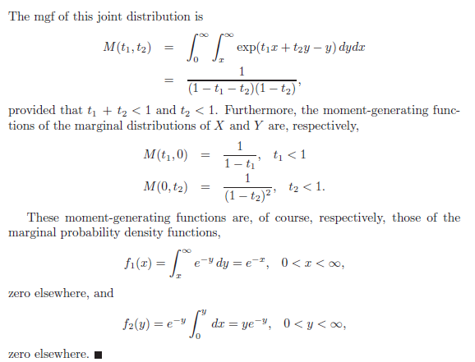

Example 2.2.1 – Non-Codable (Reason: Theoretical example with the purpose of proving a concept) 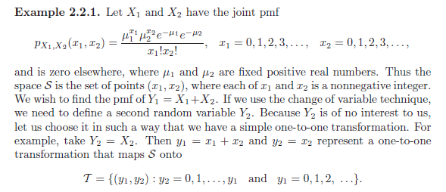

Example 2.2.2 – Non-Codable (Reason: Theoretical example with the purpose of proving a concept) 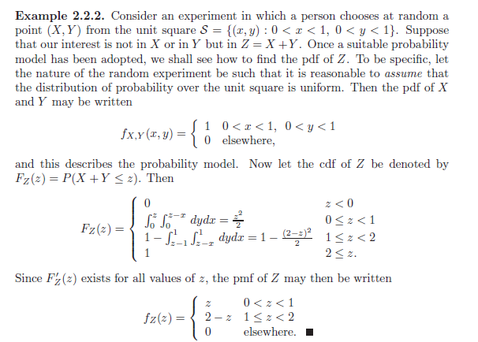

Example 2.2.3 – Non-Codable (Reason: Theoretical example, no numeric calculations) 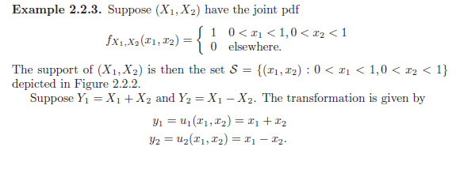 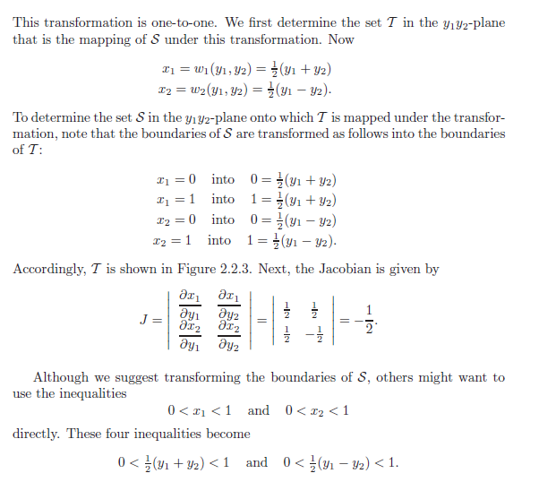

Example 2.2.4 – Non-Codable (Reason: Theoretical example, no numeric calculations) 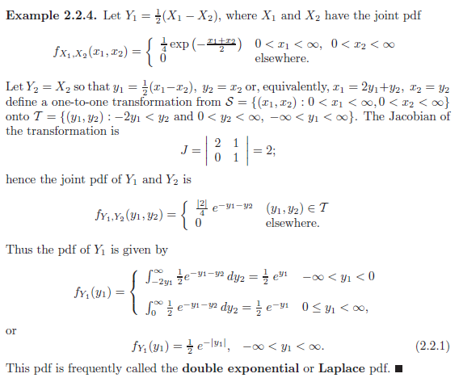

Example 2.2.5 – Non-Codable (Reason: Theoretical example, no numeric calculations) 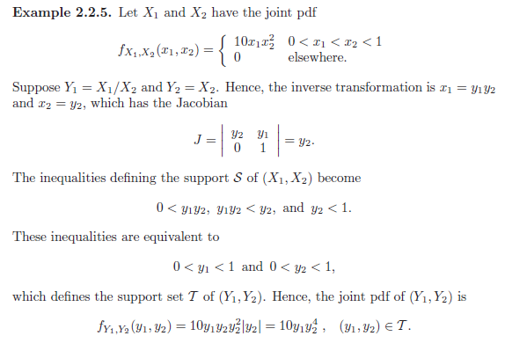 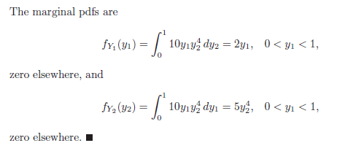

Example 2.2.6 – Non-Codable (Reason: Theoretical example, no numeric calculations) 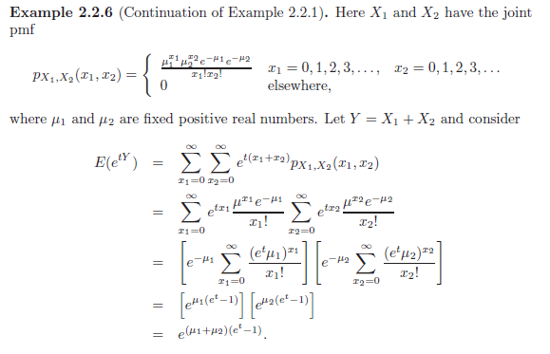 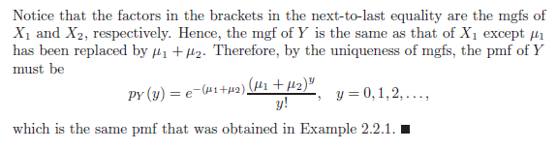

Example 2.2.7 – Non-Codable (Reason: Theoretical example, no numeric calculations) 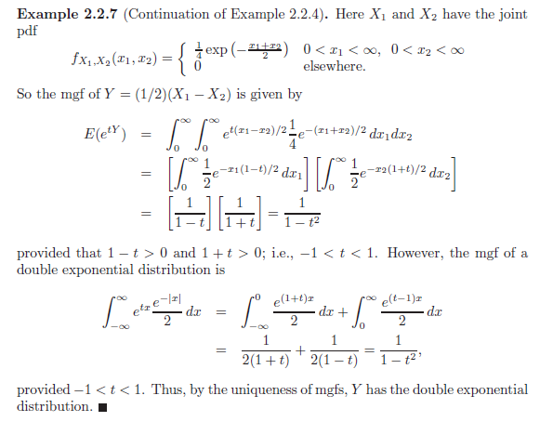

Example 2.3.1 – Codable

Example 2.3.2 – Codable

Example 2.3.3 – Non-Codable (Reason: Theoretical example, no numeric calculations) 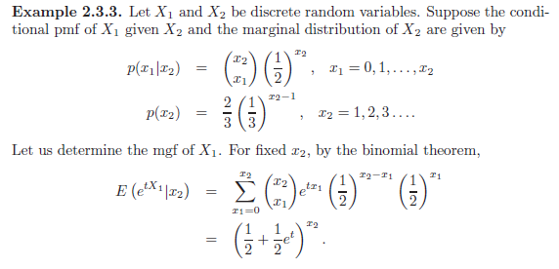 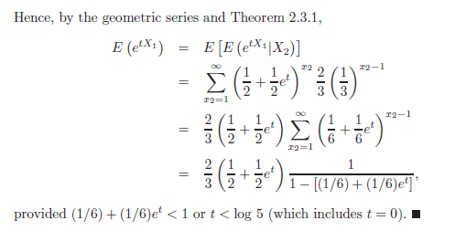

Example 2.4.1 – Codable

Example 2.4.2 – Non-Codable (Reason: Theoretical example with the purpose of proving a concept)

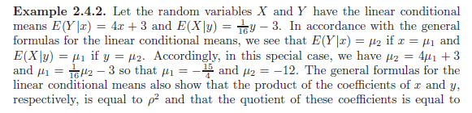 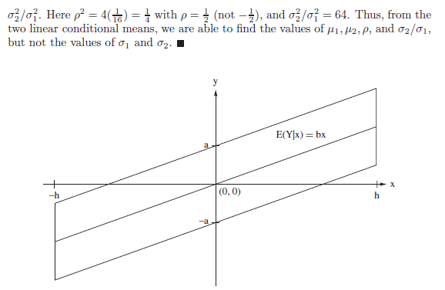

Example 2.4.3 – Non-Codable (Reason: Theoretical example, no numeric calculations)

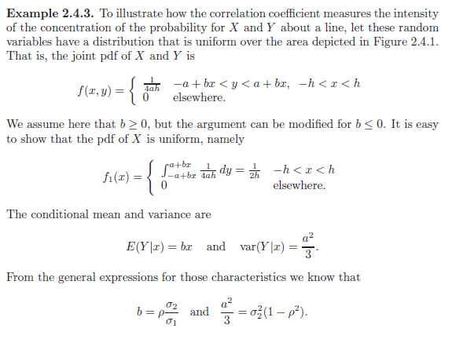 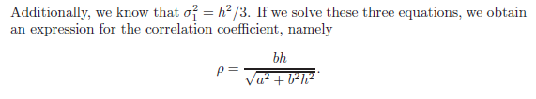

Example 2.4.4 – Non-Codable (Reason: Theoretical example, no numeric calculations) 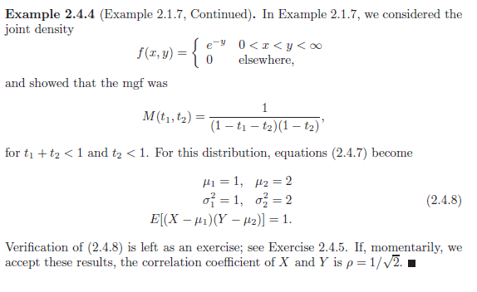

Example 2.5.1 – Non-Codable (Reason: Theoretical example with the purpose of proving a concept)

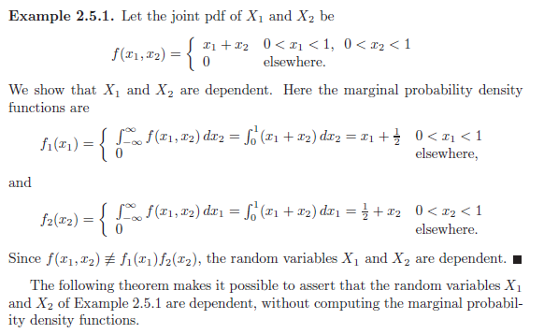

Example 2.5.2 – Non-Codable (Reason: Theoretical example with the purpose of proving a concept)

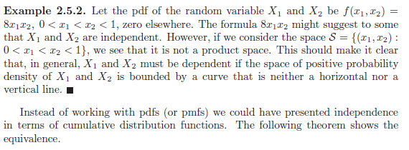

Example 2.5.3 – Codable

Example 2.5.4 – Non-Codable (Reason: Theoretical example with the purpose of proving a concept)

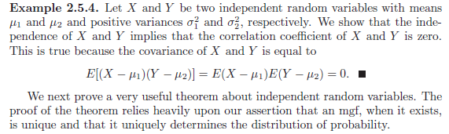

Example 2.5.5 – Non-Codable (Reason: Theoretical example, no numeric calculations)

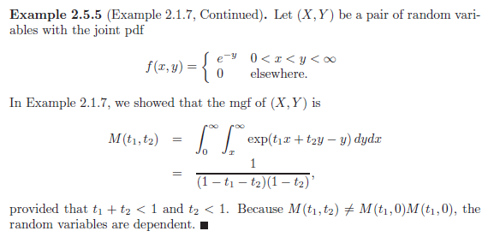

Example 2.5.6 – Non-Codable (Reason: Theoretical example, no numeric calculations) 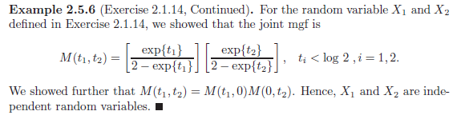

Example 2.6.1 – Non-Codable (Reason: Theoretical example with the purpose of proving a concept) 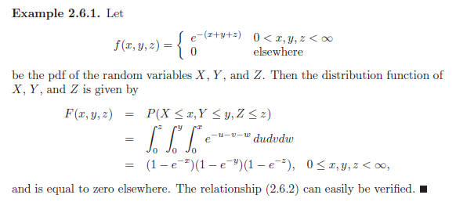

Example 2.6.2 - Codable

Example 2.6.3 – Non-Codable (Reason: Theoretical example with the purpose of proving a concept) 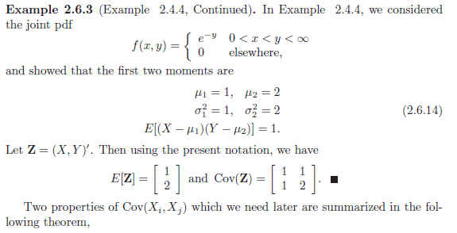

Example 2.7.1 – Non-Codable (Reason: Theoretical example with the purpose of proving a concept)

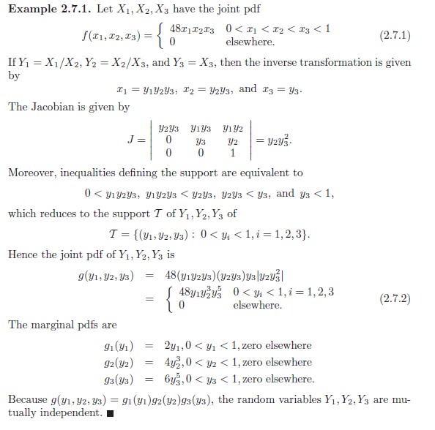

Example 2.7.2 – Non-Codable (Reason: Theoretical example with the purpose of proving a concept) 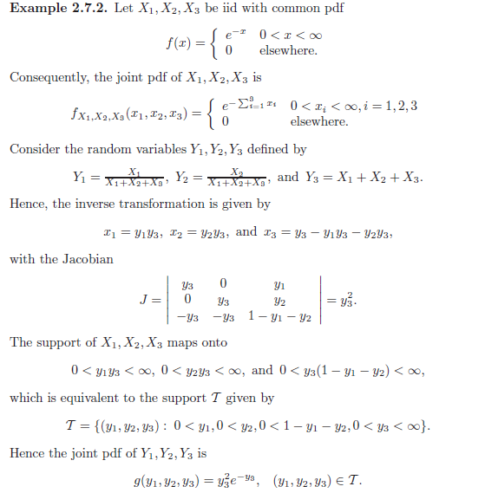 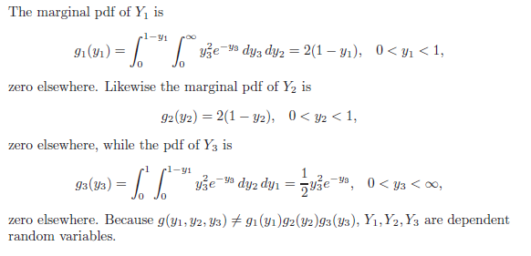

Example 2.7.3 – Non-Codable (Reason: Theoretical example, no numeric calculations) 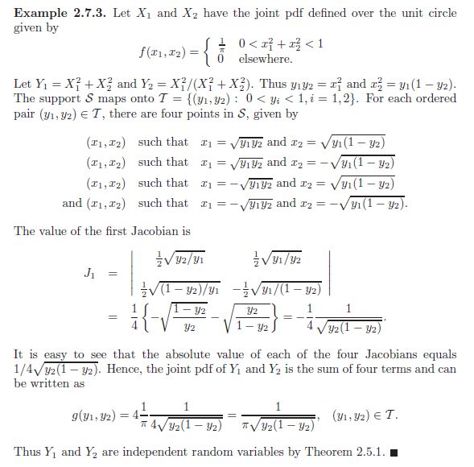

Example 2.7.4 – Non-Codable (Reason: Theoretical example, no numeric calculations) 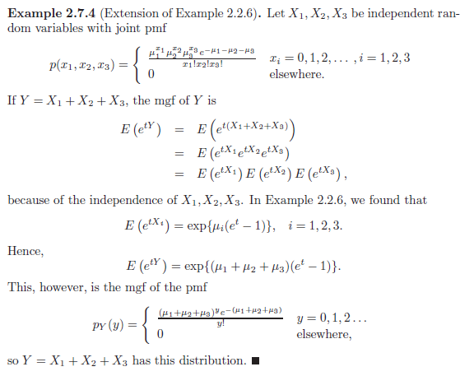

Example 2.7.5 – Non-Codable (Reason: Theoretical example, no numeric calculations) 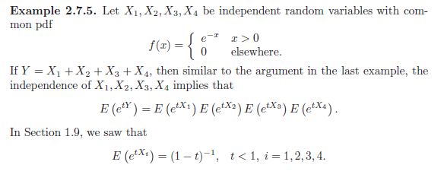

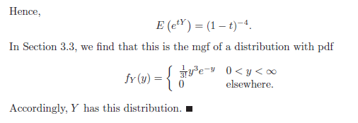

Example 2.8.1 – Non-Codable (Reason: Theoretical example with the purpose of proving a concept) 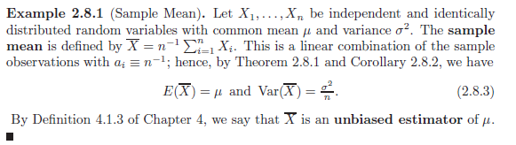

Example 2.8.2 – Non-Codable (Reason: Theoretical example with the purpose of proving a concept) 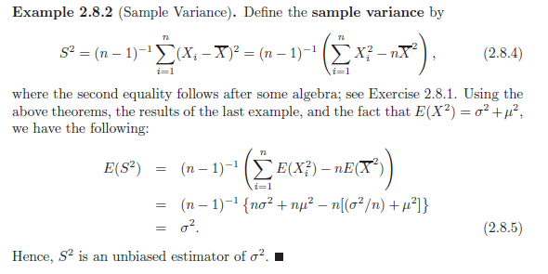

**Chapter 3: Some Special Distributions**

Example 3.1.1 - Codable

Example 3.1.2 - Codable

Example 3.1.3 – Non-Codable (Reason: Theoretical example, no numeric calculations) 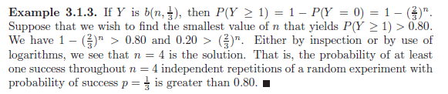

Example 3.1.4 – Non-Codable (Reason: Theoretical example with the purpose of proving a concept) 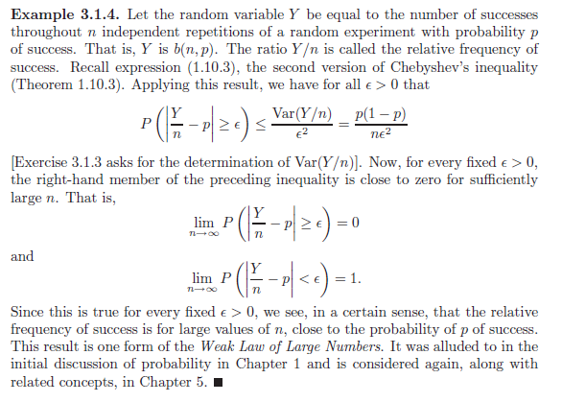

Example 3.1.5 – Non-Codable (Reason: Theoretical example with the purpose of proving a concept) 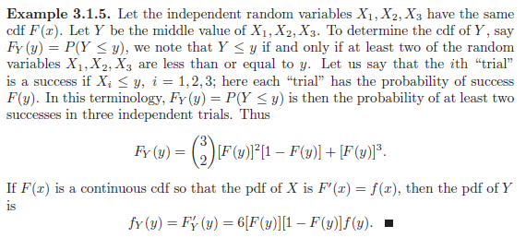

Example 3.1.6 – Non-Codable (Reason: Theoretical example with the purpose of proving a concept) 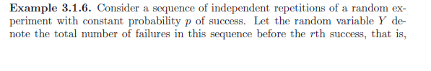 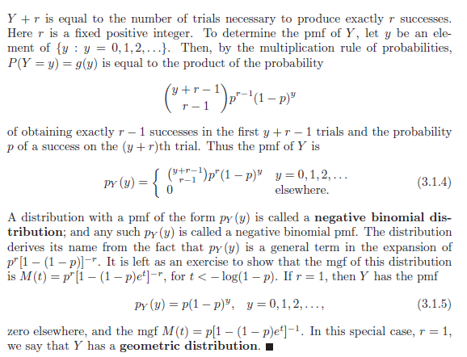

Example 3.1.7 – Non-Codable (Reason: Theoretical example with the purpose of proving a concept) 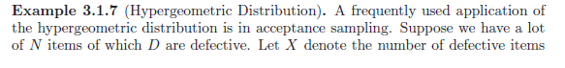 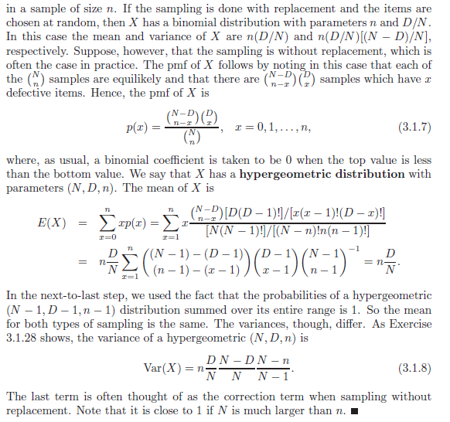

Example 3.2.1 – Codable

Example 3.2.2 - Codable

Example 3.2.3 - Codable

Example 3.2.4 - Codable

Example 3.3.1 – Non-Codable (Reason: Theoretical example with the purpose of proving a concept) 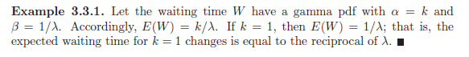

Example 3.3.2 – Non-Codable (Reason: Theoretical example with the purpose of proving a concept) 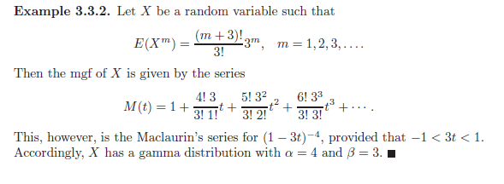

Example 3.3.3 - Non-Codable (Reason: Theoretical example, no numeric calculations) 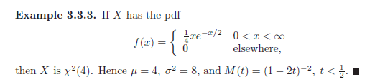

Example 3.3.4 – Non-Codable (Reason: Theoretical example with the purpose of proving a concept) 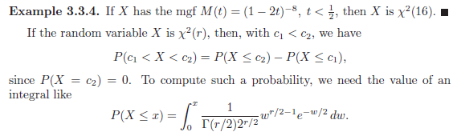

Example 3.3.5 - Codable

Example 3.3.6 – Non-Codable (Reason: Theoretical example with the purpose of proving a concept) 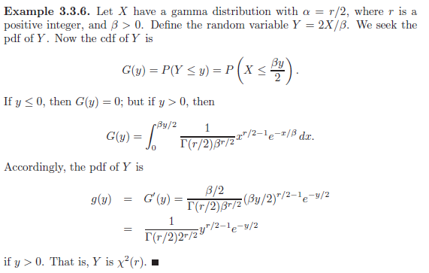

Example 3.3.7 – Non-Codable (Reason: Theoretical example with the purpose of proving a concept) 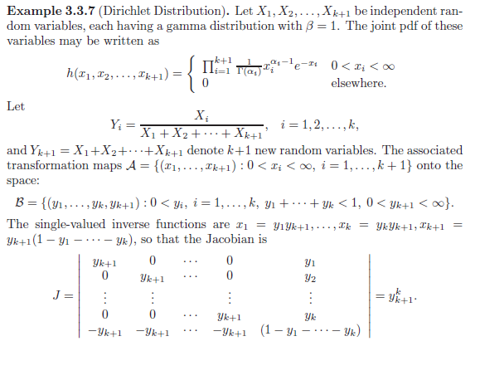 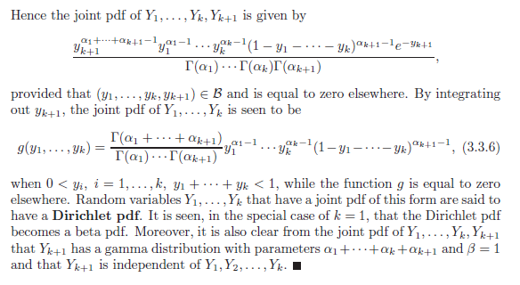

Example 3.4.1 – Non-Codable (Reason: Theoretical example with the purpose of proving a concept) 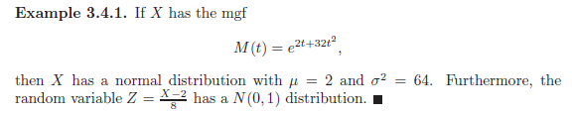

Example 3.4.2 – Non-Codable (Reason: Theoretical example with the purpose of proving a concept) 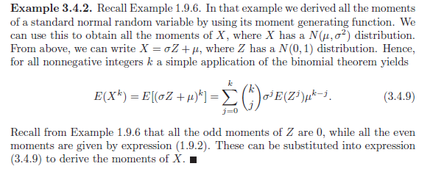

Example 3.4.3 – Codable

Example 3.4.4 – Codable

Example 3.4.5 – Non-Codable (Reason: Cannot find missing variables) 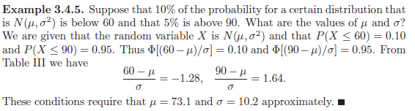

Example 3.5.1 – Non-Codable (Reason: Theoretical example with the purpose of proving a concept) 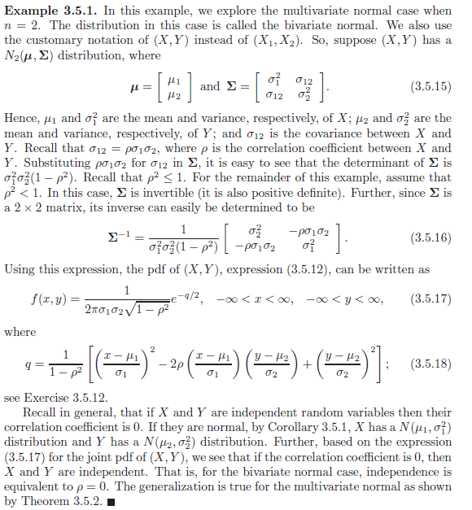

Example 3.5.2 – Non-Codable (Reason: Theoretical example with the purpose of proving a concept) 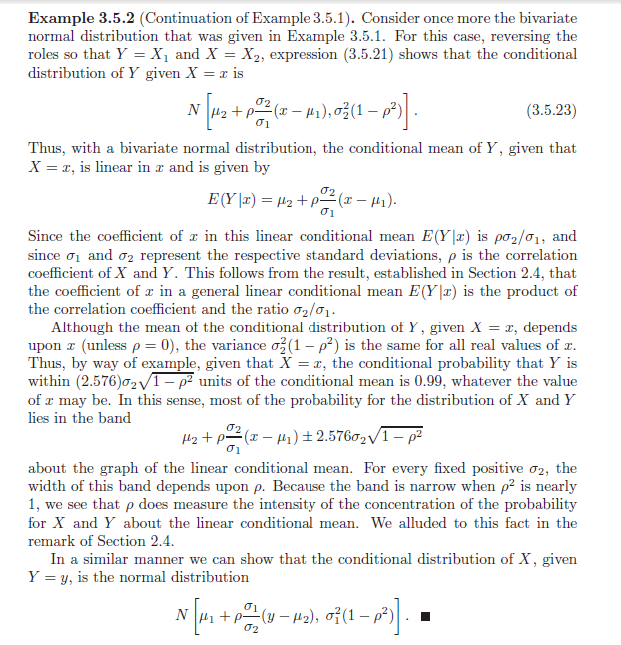

Example 3.5.3 – Codable

Example 3.6.1 - Non-Codable (Reason: Theoretical example with the purpose of proving a concept) 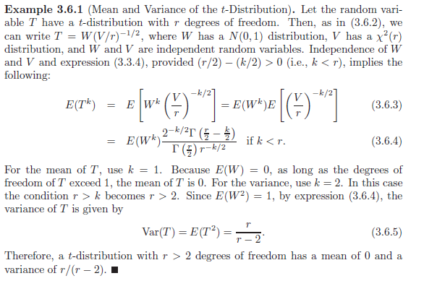

Example 3.6.2 - Non-Codable (Reason: Theoretical example with the purpose of proving a concept) 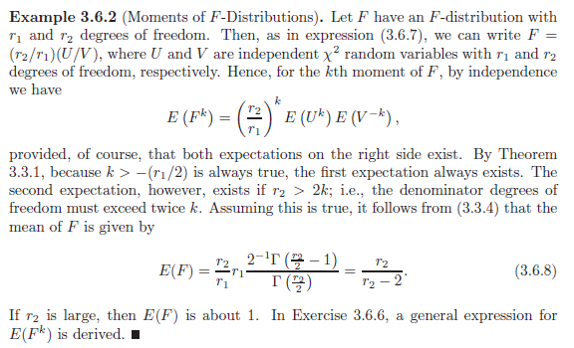

Example 3.7.1 - Non-Codable (Reason: Theoretical example with the purpose of proving a concept) 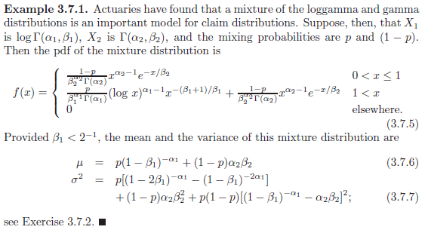

Example 3.7.2 - Non-Codable (Reason: Theoretical example with the purpose of proving a concept) 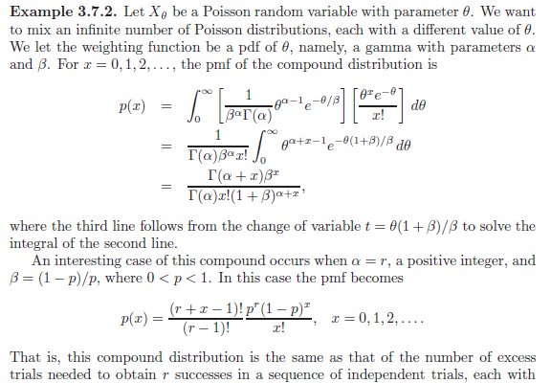 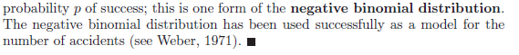

Example 3.7.3 - Non-Codable (Reason: Theoretical example with the purpose of proving a concept) 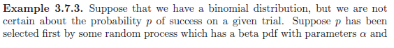 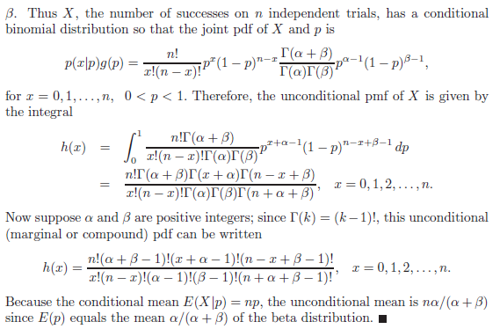

Example 3.7.4 - Non-Codable (Reason: Theoretical example with the purpose of proving a concept) 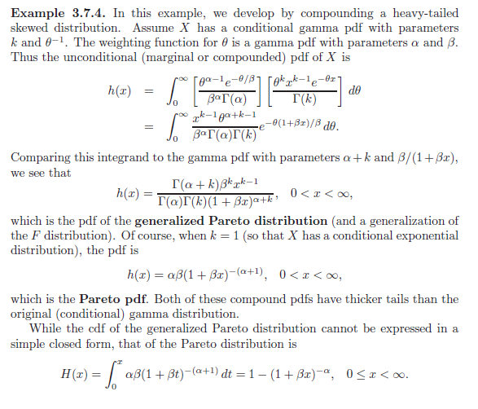 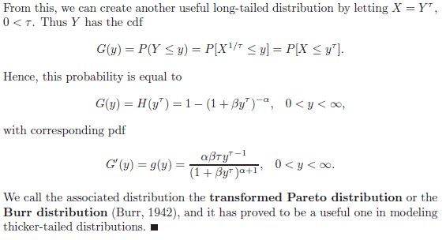

**Chapter 4: Some Elementary Statistical Inferences**

Example 4.1.1 – Non-Codable (Reason: Theoretical example with the purpose of proving a concept) 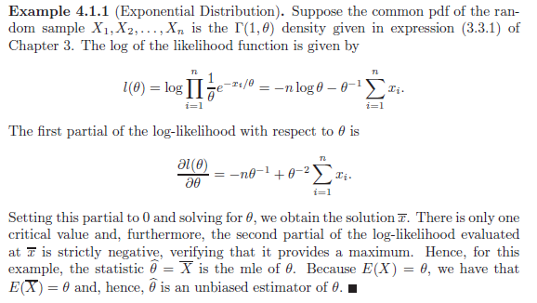

Example 4.1.2 – Non-Codable (Reason: Theoretical example with the purpose of proving a concept) 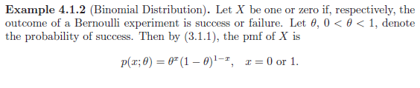 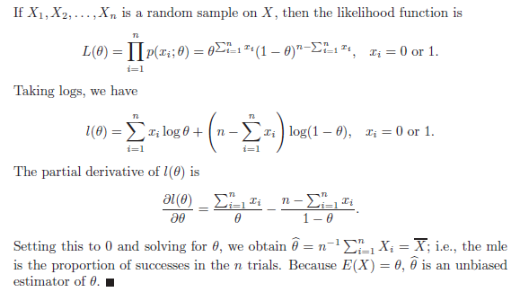

Example 4.1.3 – Non-Codable (Reason: Theoretical example with the purpose of proving a concept) 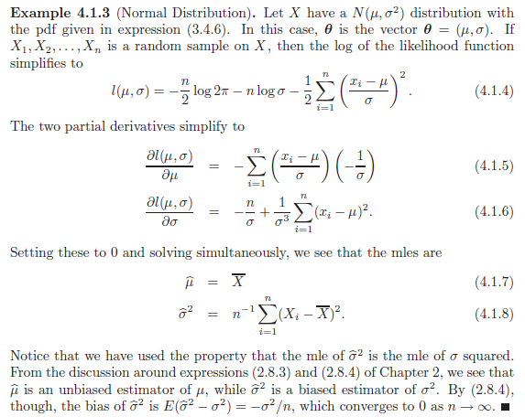

Example 4.1.4 – Non-Codable (Reason: Theoretical example with the purpose of proving a concept) 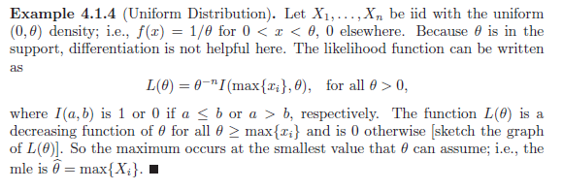

Example 4.1.5 – Codable

Example 4.1.6 – Codable

Example 4.1.7 – Codable

Example 4.2.1 – Non-Codable (Reason: Theoretical example with the purpose of proving a concept) 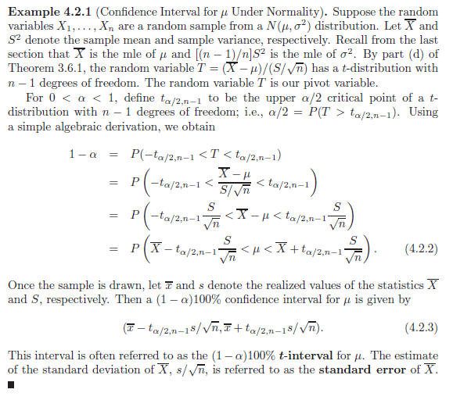

Example 4.2.2 – Non-Codable (Reason: Theoretical example with the purpose of proving a concept) 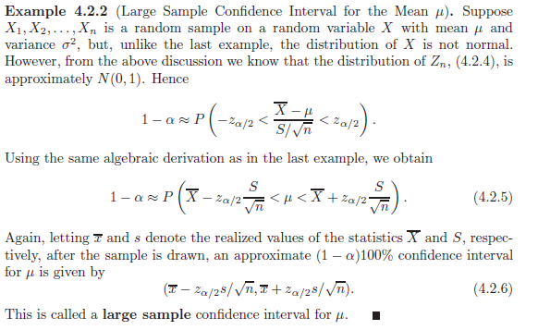

Example 4.2.3 – Non-Codable (Reason: Theoretical example with the purpose of proving a concept) 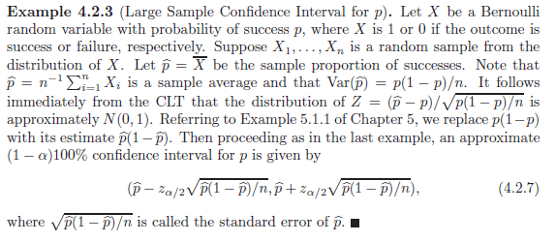

Example 4.2.4 – Non-Codable (Reason: Cannot find confidence interval range)  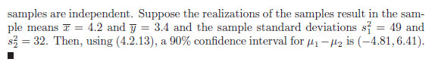

Example 4.2.5 – Non-Codable (Reason: Cannot find confidence interval range) 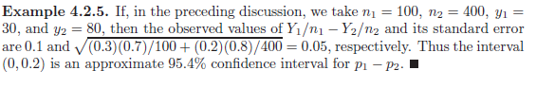

Example 4.3.1 – Non-Codable (Reason: Theoretical example with the purpose of proving a concept) 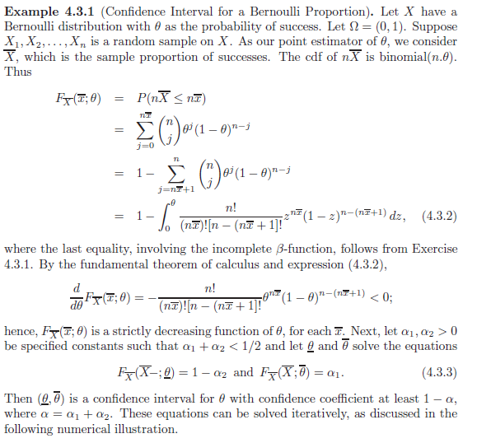

Example 4.3.2 – Non-Codable (Reason: Theoretical example with the purpose of proving a concept)

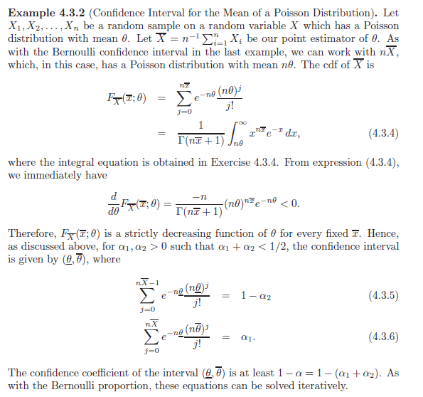

Example 4.4.1 – Non-Codable (Reason: Integration of unknown variables) 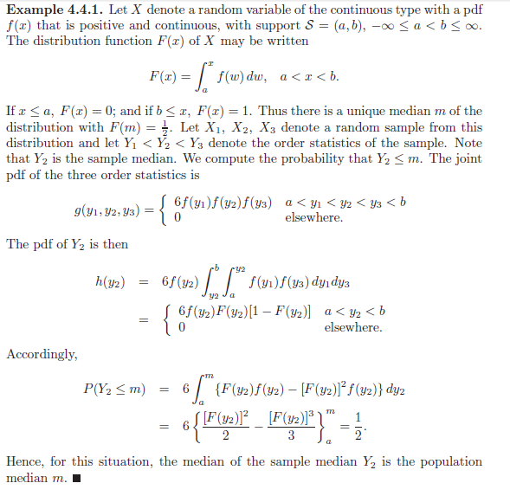

Example 4.4.2 – Non-Codable (Reason: Theoretical example with the purpose of proving a concept) 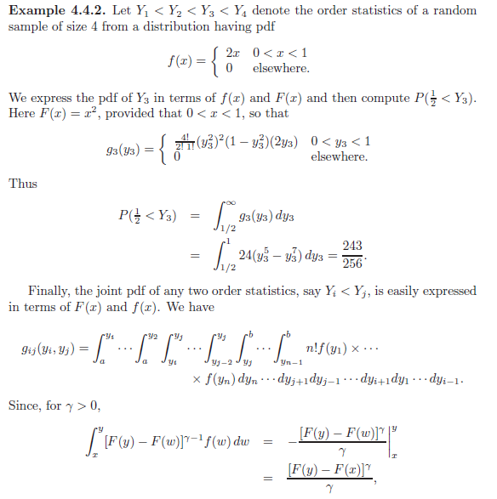 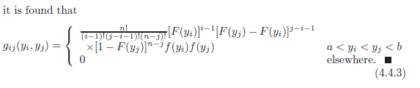

Example 4.4.3 – Non-Codable (Reason: Theoretical example with the purpose of proving a concept) 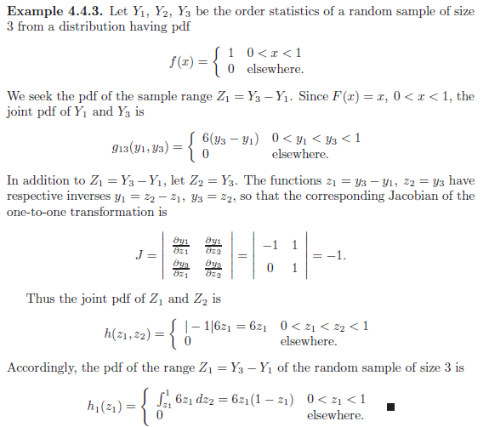

Example 4.4.4 – Non-Codable (Reason: Theoretical example with the purpose of proving a concept) 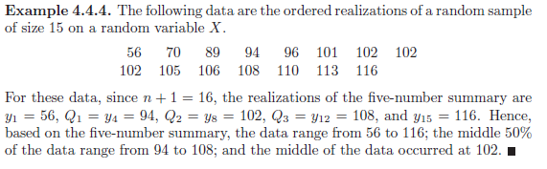

Example 4.4.5 – Codable

Example 4.4.6 – Non-Codable (Reason: Theoretical example with the purpose of proving a concept)  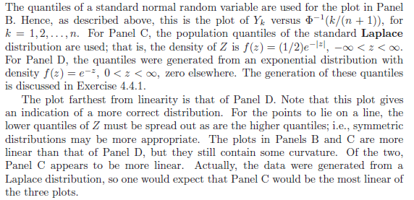

Example 4.4.7 – Non-Codable (Reason: Theoretical example with the purpose of proving a concept) 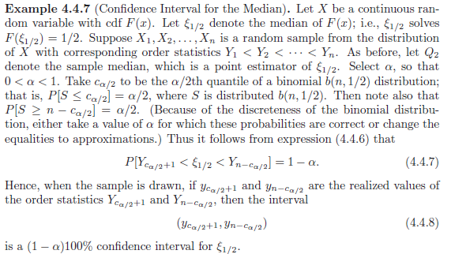

Example 4.5.1 – Non-Codable (Reason: Theoretical example with the purpose of proving a concept) 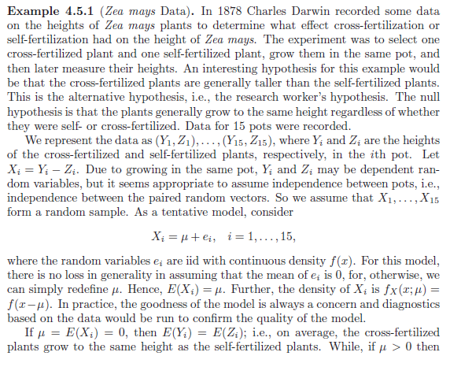 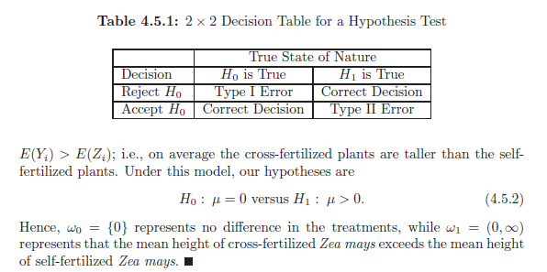

Example 4.5.2 – Non-Codable (Reason: Theoretical example with the purpose of proving a concept) 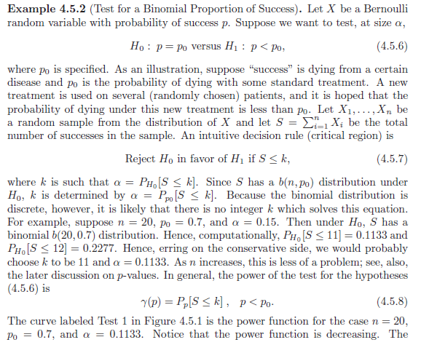 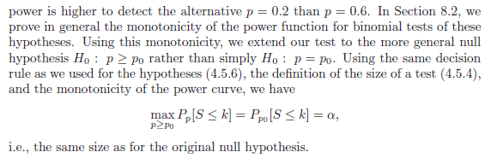

Example 4.5.3 – Non-Codable (Reason: Theoretical example with the purpose of proving a concept) 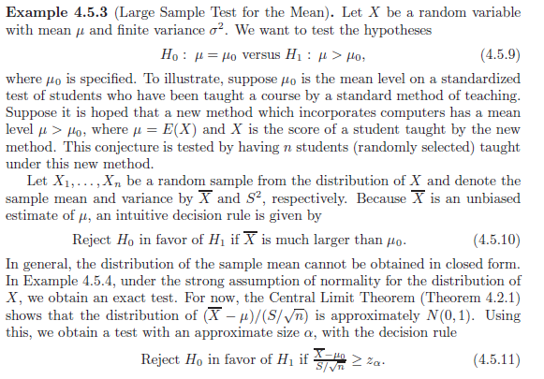 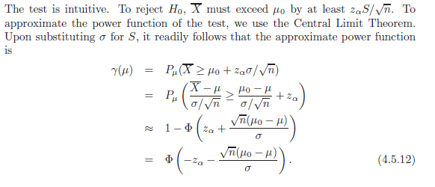 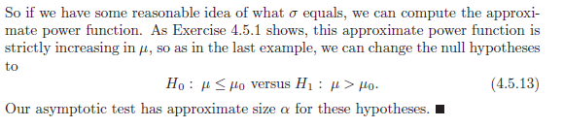

Example 4.5.4 – Non-Codable (Reason: Theoretical example with the purpose of proving a concept) 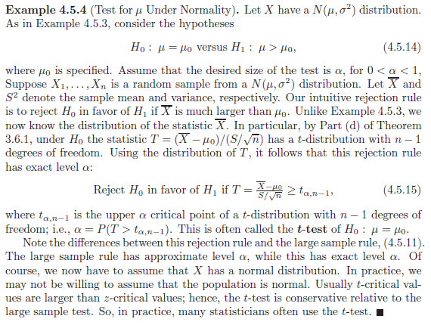

Example 4.5.5 – Codable

Example 4.6.1 – Non-Codable (Reason: Theoretical example with the purpose of proving a concept) 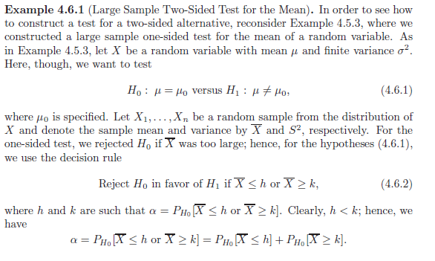 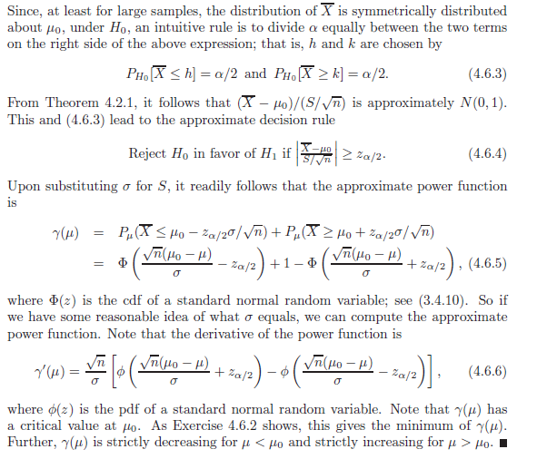

Example 4.6.2 – Non-Codable (Reason: Theoretical example with the purpose of proving a concept) 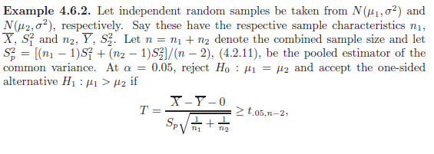 

Example 4.6.3 – Non-Codable (Reason: Theoretical example with the purpose of proving a concept) 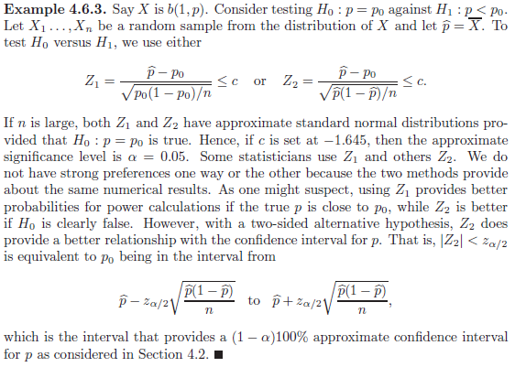

Example 4.6.4 –Codable

Example 4.6.5 – Non-Codable (Reason: Checking rejection or acceptance of hypothesis)

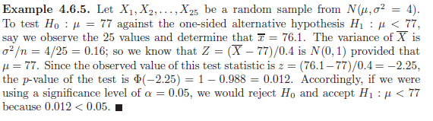

Example 4.7.1 – Codable

Example 4.7.2 – Codable

Example 4.7.3 – Non-Codable (Reason: Theoretical example with the purpose of proving a concept) 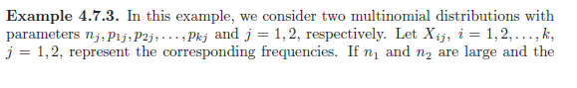 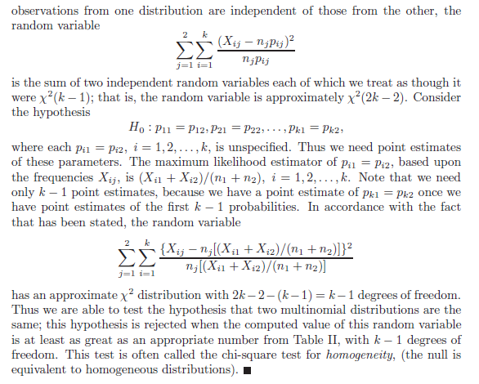

Example 4.7.4 – Non-Codable (Reason: Theoretical example with the purpose of proving a concept) 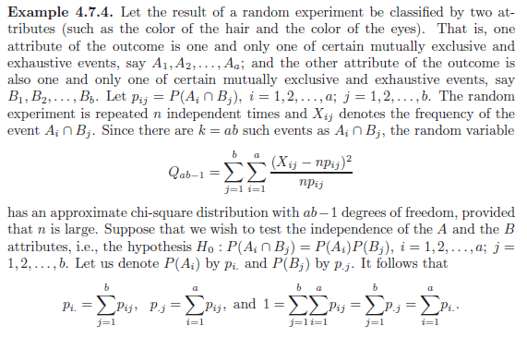 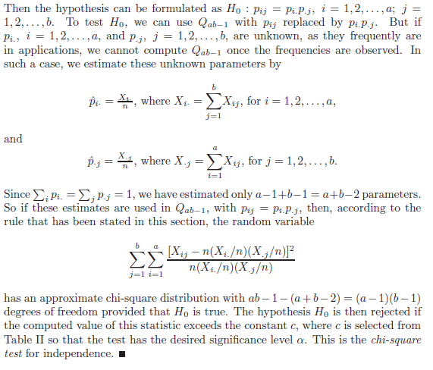

Example 4.8.1– Non-Codable (Reason: Theoretical example, no numeric calculations) 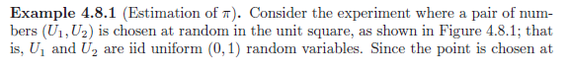 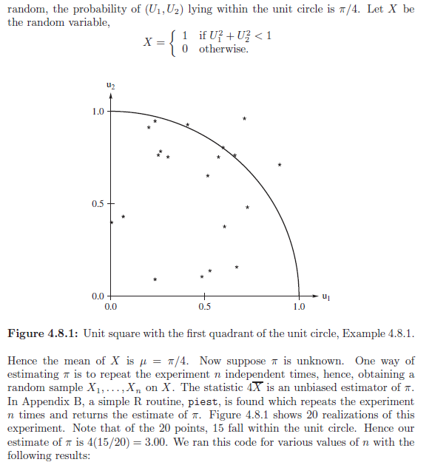 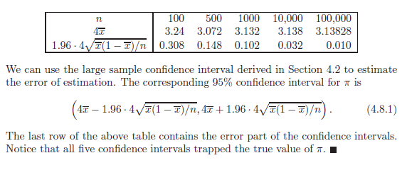

Example 4.8.2– Non-Codable (Reason: Theoretical example, no numeric calculations) 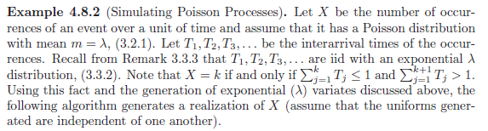 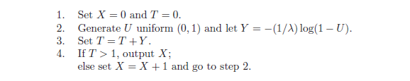

Example 4.8.3 – Non-Codable (Reason: Theoretical example with the purpose of proving a concept) 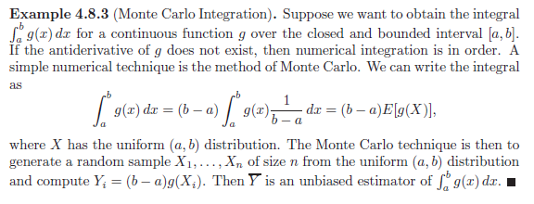

Example 4.8.4– Non-Codable (Reason: Theoretical example, no numeric calculations) 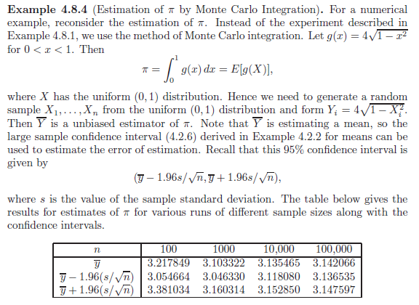 

Example 4.8.5– Non-Codable (Reason: Theoretical example, no numeric calculations) 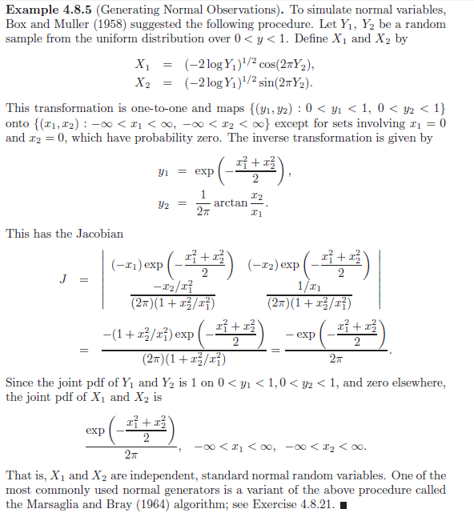

Example 4.8.6– Non-Codable (Reason: Theoretical example, no numeric calculations) 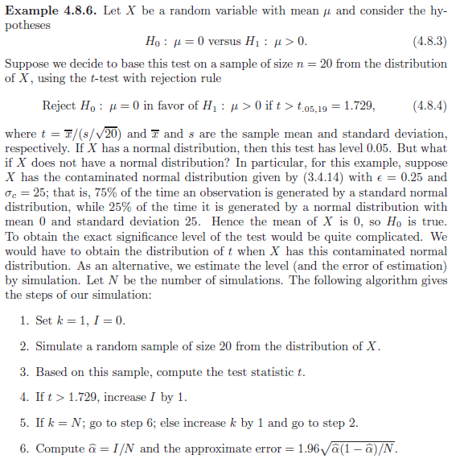

Example 4.8.7– Non-Codable (Reason: Theoretical example, no numeric calculations)  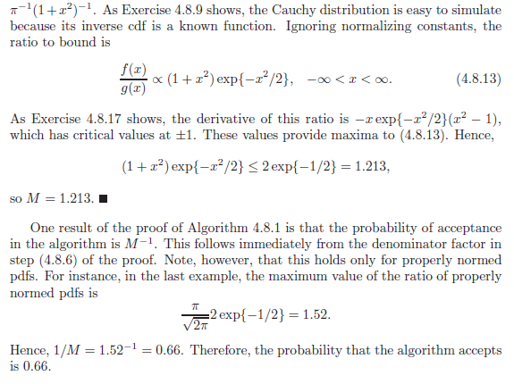

Example 4.9.1 – Non-Codable (Example code found in appendix) 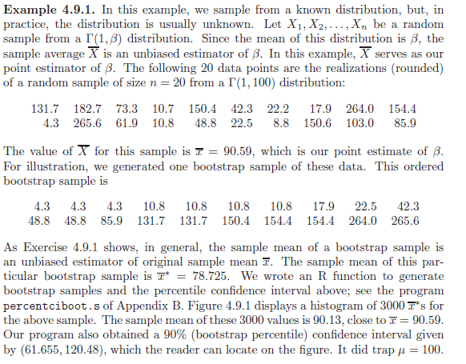 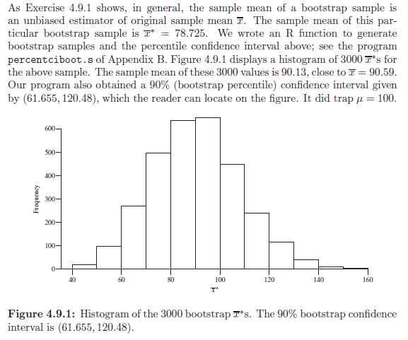

Example 4.9.2 – Non-Codable (Example code found in appendix) 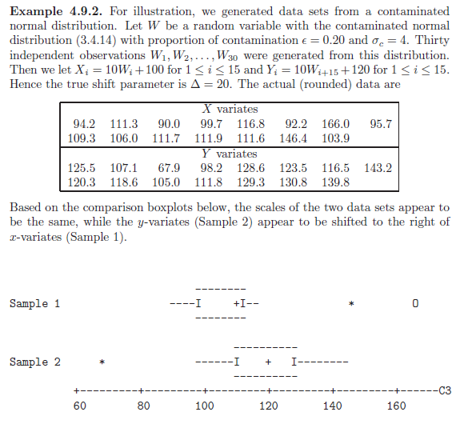 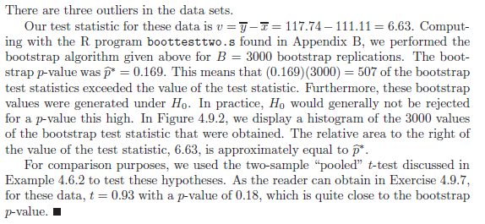

Example 4.9.3 – Non-Codable (Example code found in appendix) 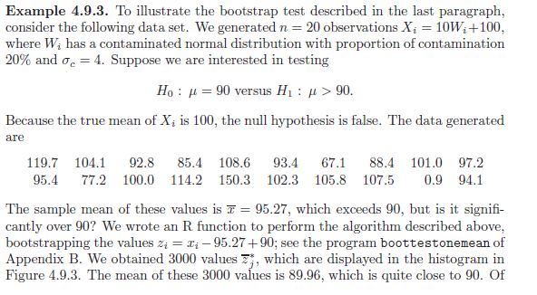 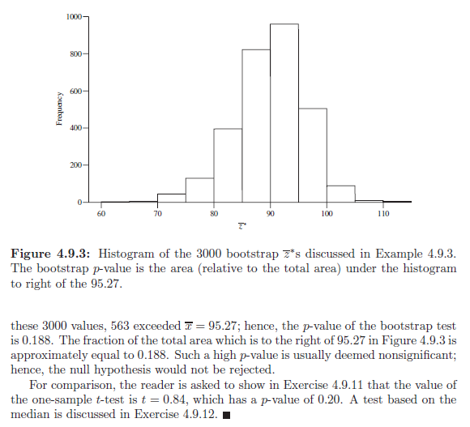

Example 4.10.1 - Codable

**Chapter 5: Consistency and Limiting Distributions**

Example 5.1.1 – Non-Codable (Reason: Theoretical example with the purpose of proving a concept) 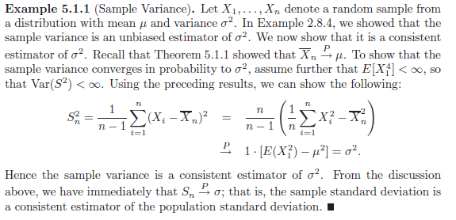

Example 5.1.2 – Non-Codable (Reason: Theoretical example with the purpose of proving a concept) 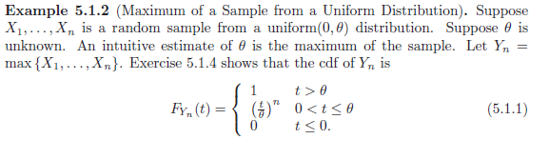 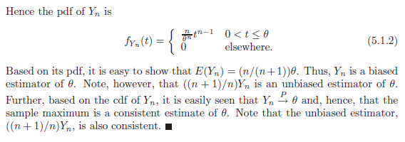

Example 5.2.1 – Non-Codable (Reason: Theoretical example, no numeric calculations) 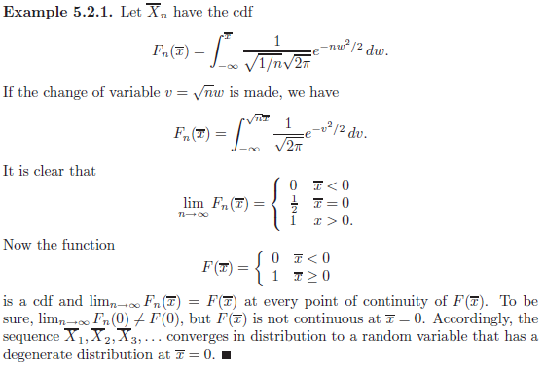

Example 5.2.2 – Non-Codable (Reason: Theoretical example, no numeric calculations) 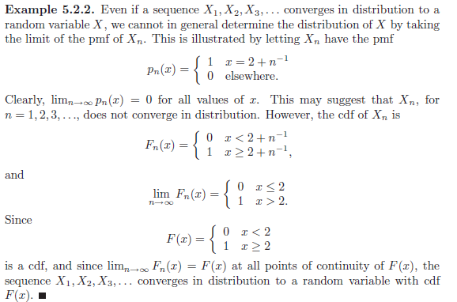

Example 5.2.3 – Non-Codable (Reason: Theoretical example, no numeric calculations) 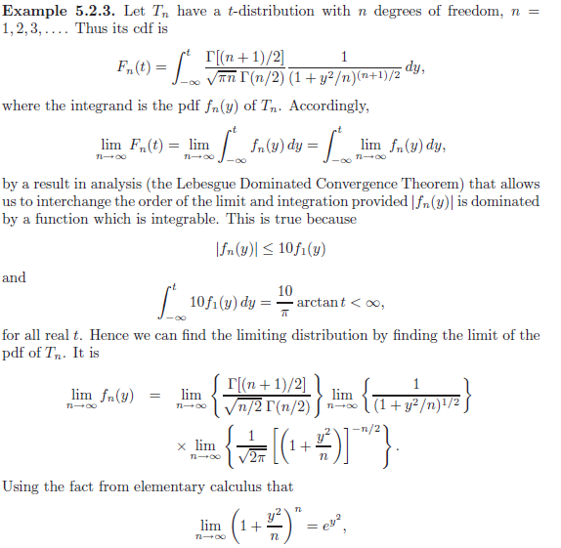 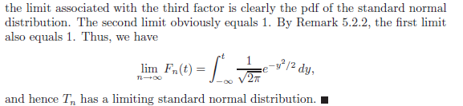

Example 5.2.4 – Non-Codable (Reason: Theoretical example, no numeric calculations) 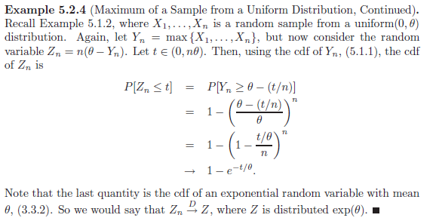

Example 5.2.5 – Non-Codable (Reason: Theoretical example, no numeric calculations) 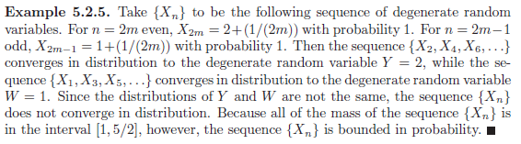

Example 5.2.6 – Codable

Example 5.2.7 – Non-Codable (Reason: Theoretical example, no numeric calculations) 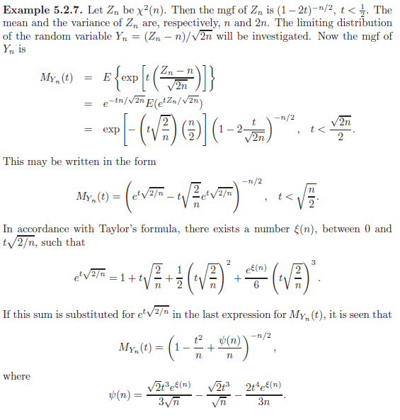 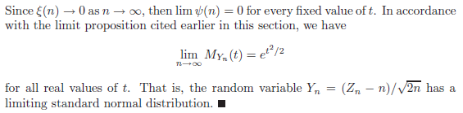

Example 5.2.8 – Non-Codable (Reason: Theoretical example, no numeric calculations) 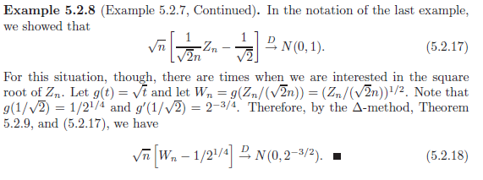

Example 5.3.1– Non-Codable (Reason: Theoretical example, no numeric calculations) 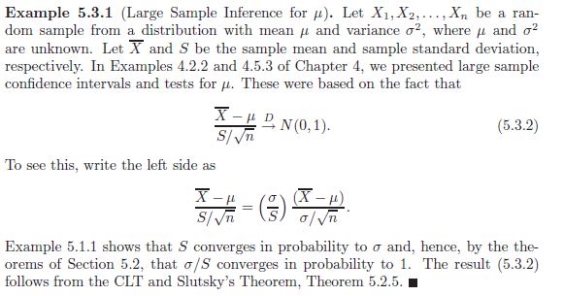

Example 5.3.2 – Codable

Example 5.3.3 – Codable

Example 5.3.4 – Codable

Example 5.3.5– Non-Codable (Reason: Theoretical example, no numeric calculations) 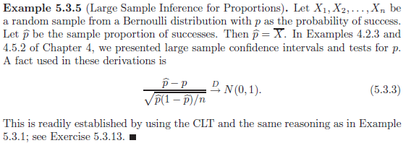

Example 5.3.6– Non-Codable (Reason: Theoretical example, no numeric calculations) 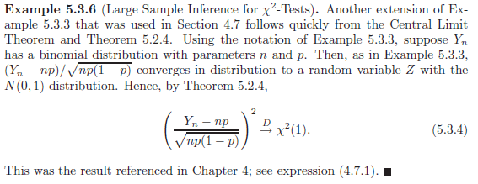

Example 5.3.7– Non-Codable (Reason: Theoretical example, no numeric calculations) 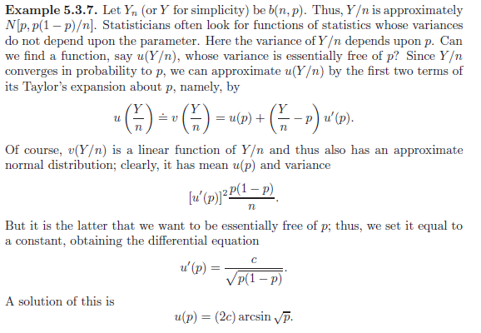 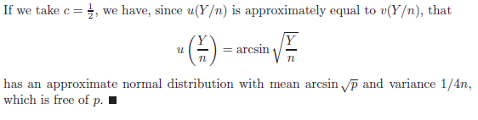

**Chapter 6: Maximum Likelihood Methods**

Example 6.1.1 – Non-Codable (Reason: Theoretical example with the purpose of proving a concept) 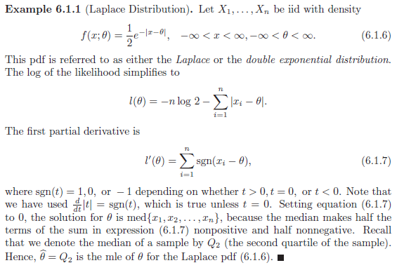

Example 6.1.2 – Non-Codable (Reason: Theoretical example with the purpose of proving a concept) 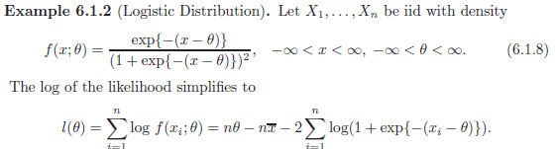 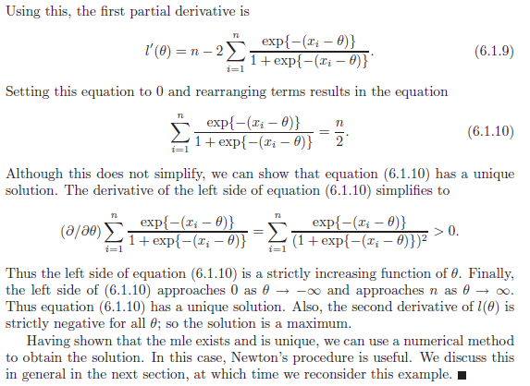

Example 6.1.3 – Non-Codable (Reason: Theoretical example with the purpose of proving a concept) 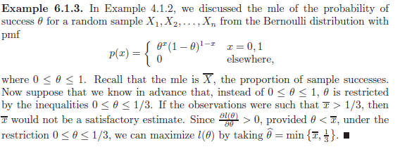

Example 6.2.1 – Non-Codable (Reason: Theoretical example with the purpose of proving a concept) 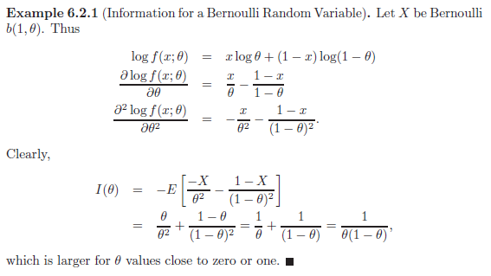

Example 6.2.2 – Non-Codable (Reason: Theoretical example with the purpose of proving a concept) 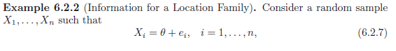 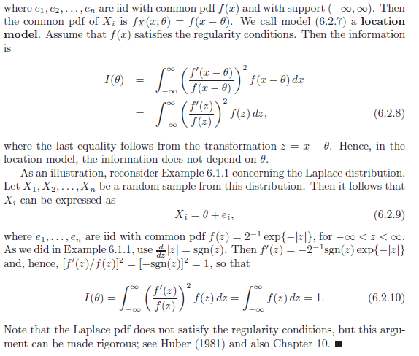

Example 6.2.3 – Non-Codable (Reason: Theoretical example with the purpose of proving a concept) 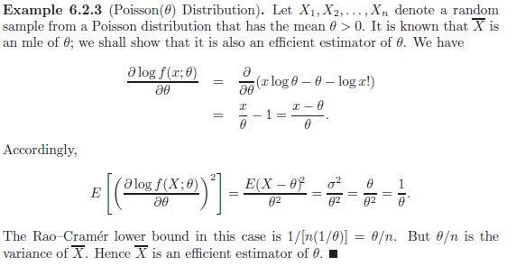

Example 6.2.4 – Non-Codable (Reason: Theoretical example with the purpose of proving a concept) 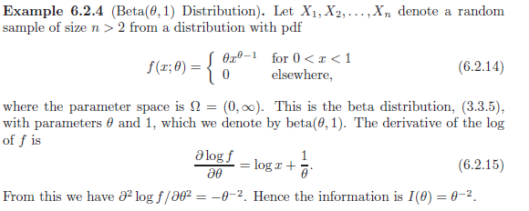 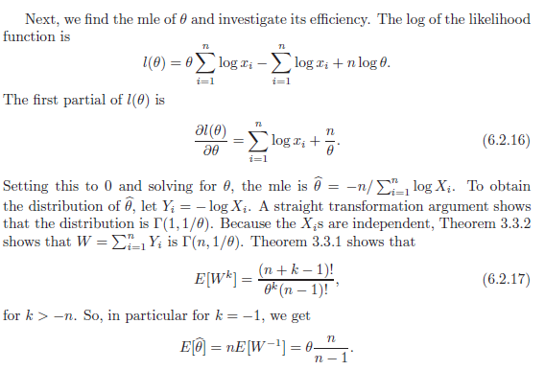 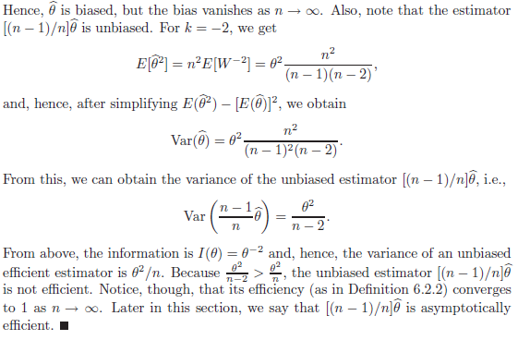

Example 6.2.5 – Non-Codable (Reason: Theoretical example with the purpose of proving a concept) 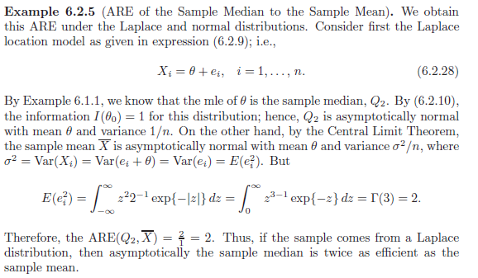

Example 6.2.6 – Non-Codable (Reason: Theoretical example with the purpose of proving a concept) 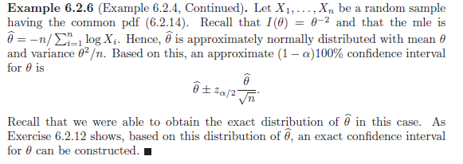

Example 6.2.7 – Non-Codable (Reason: Theoretical example with the purpose of proving a concept) 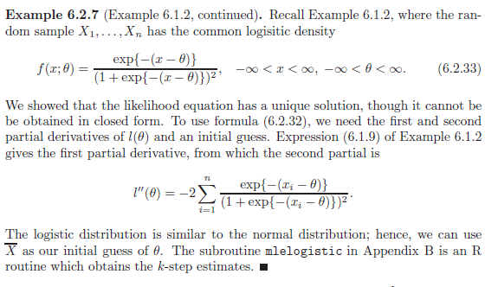

Example 6.3.1 – Non-Codable (Reason: Theoretical example with the purpose of proving a concept) 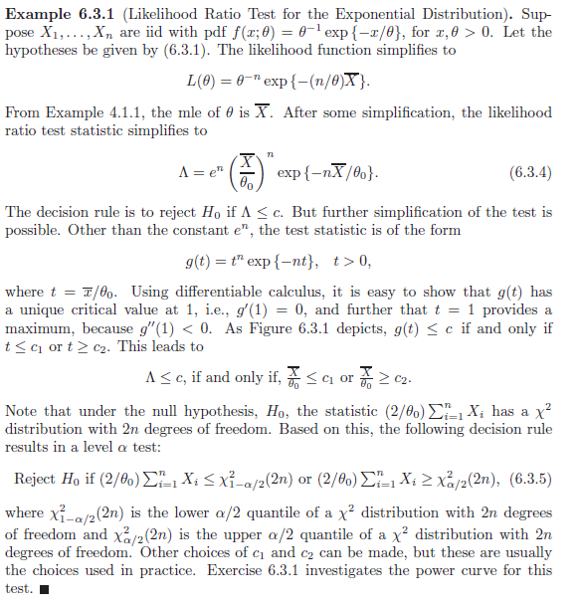

Example 6.3.2 – Non-Codable (Reason: Theoretical example with the purpose of proving a concept) 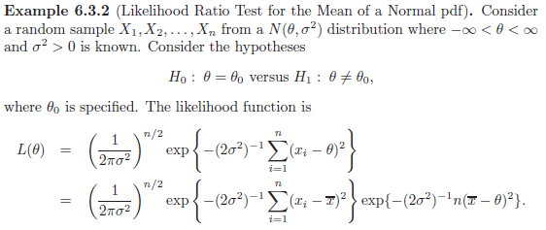 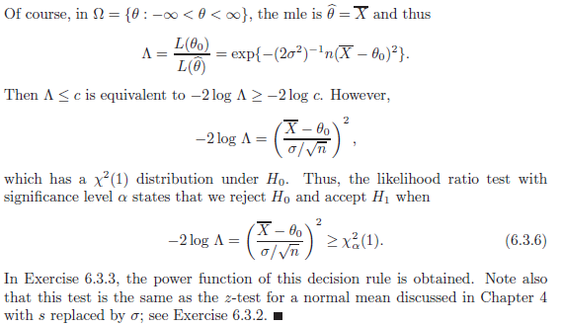

Example 6.3.3 – Non-Codable (Reason: Theoretical example with the purpose of proving a concept) 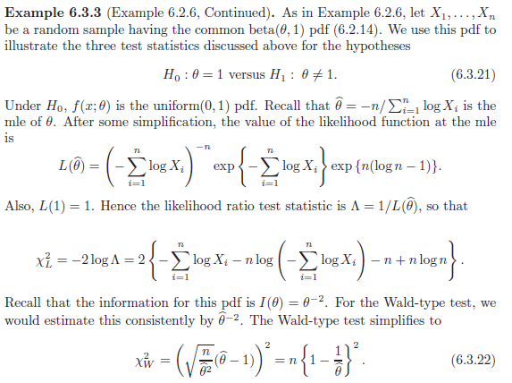 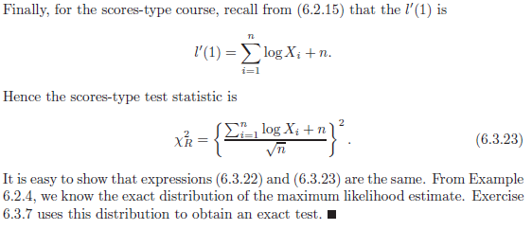

Example 6.3.4 – Non-Codable (Reason: Theoretical example with the purpose of proving a concept) 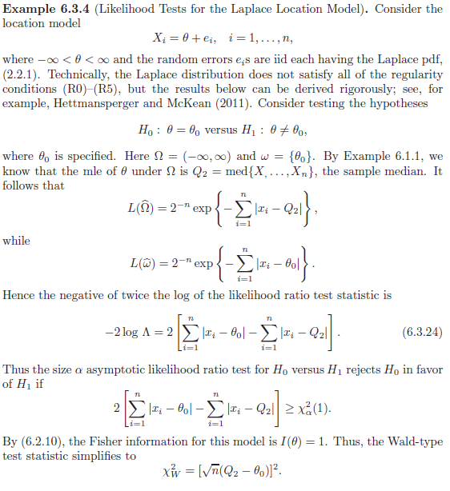 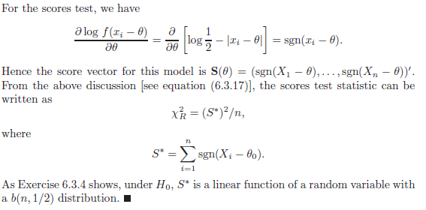

Example 6.4.1 – Non-Codable (Reason: Theoretical example with the purpose of proving a concept) 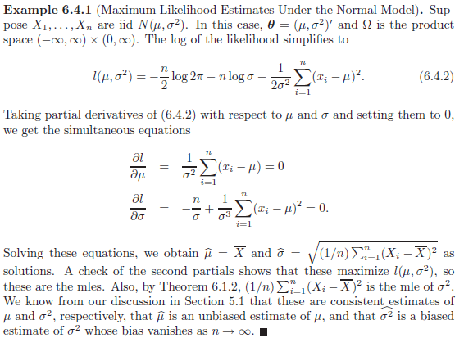

Example 6.4.2 – Non-Codable (Reason: Theoretical example with the purpose of proving a concept) 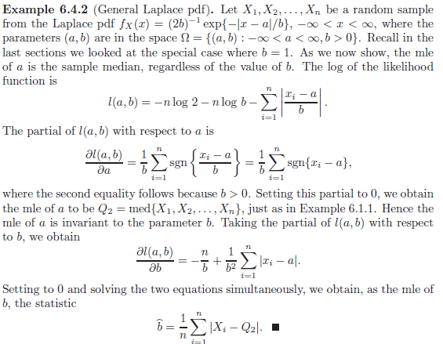

Example 6.4.3 – Non-Codable (Reason: Theoretical example with the purpose of proving a concept) 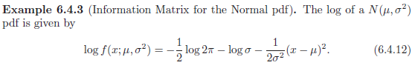 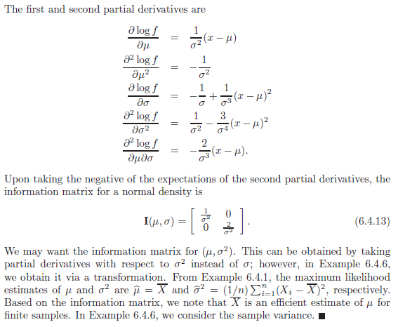

Example 6.4.4 – Non-Codable (Reason: Theoretical example with the purpose of proving a concept) 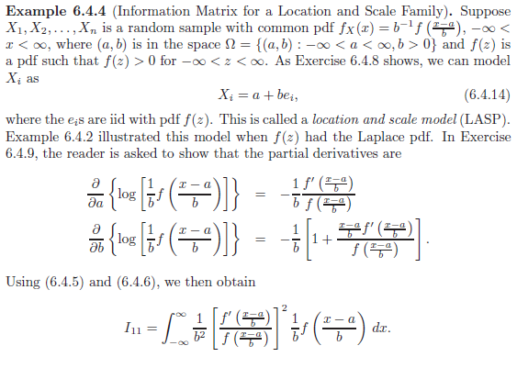 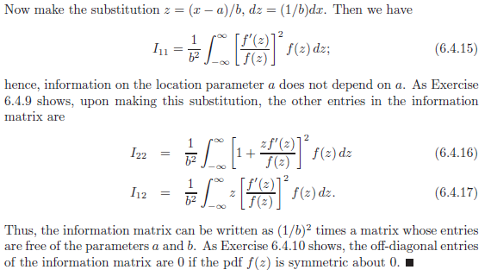

Example 6.4.5 – Non-Codable (Reason: Theoretical example with the purpose of proving a concept) 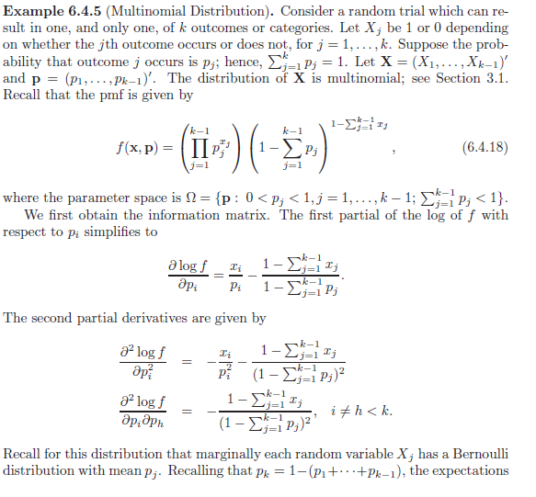 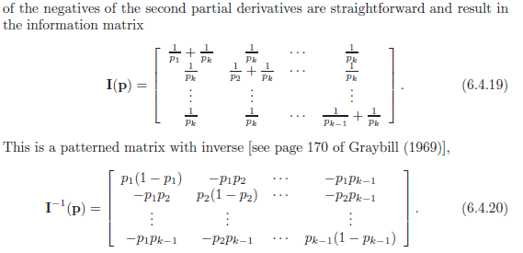 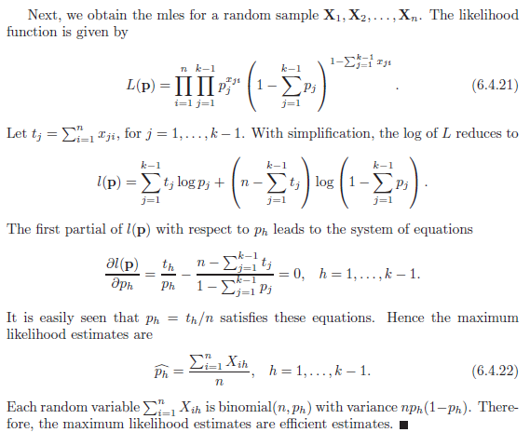

Example 6.4.6 – Non-Codable (Reason: Theoretical example with the purpose of proving a concept) 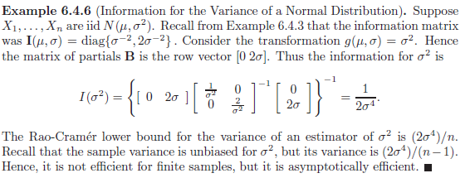

Example 6.5.1 – Non-Codable (Reason: Theoretical example with the purpose of proving a concept) 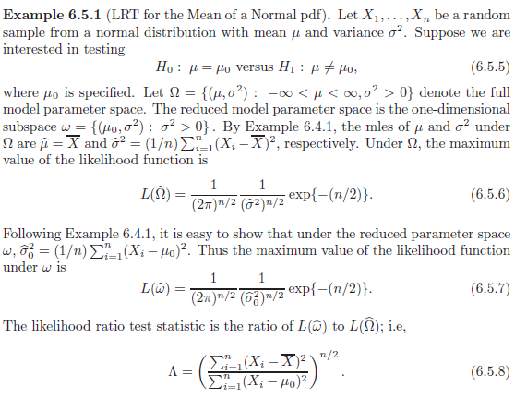 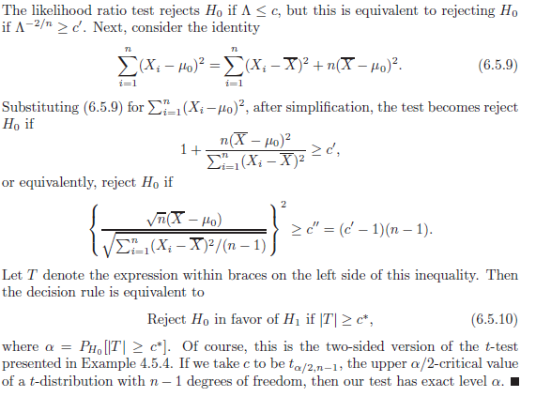

Example 6.5.2 – Non-Codable (Reason: Theoretical example with the purpose of proving a concept) 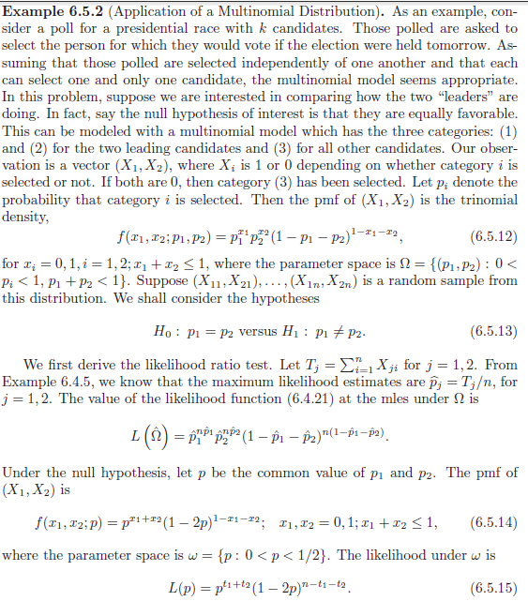 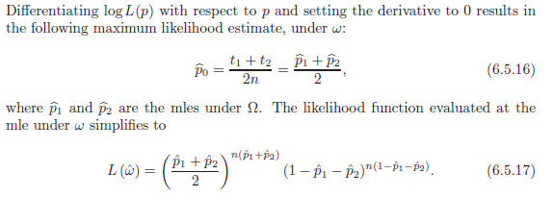 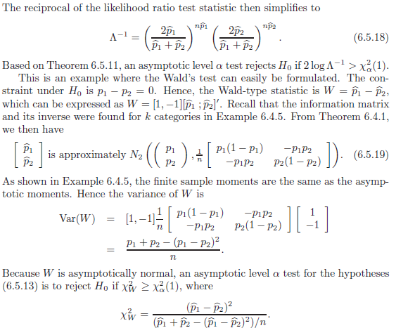 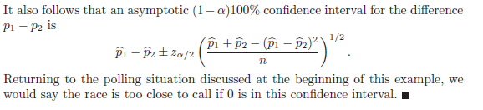

Example 6.5.3 – Non-Codable (Reason: Theoretical example with the purpose of proving a concept) 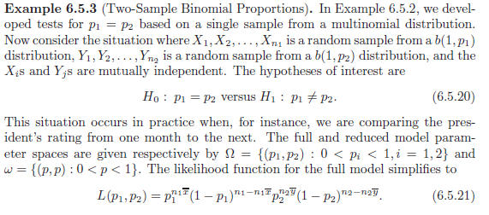 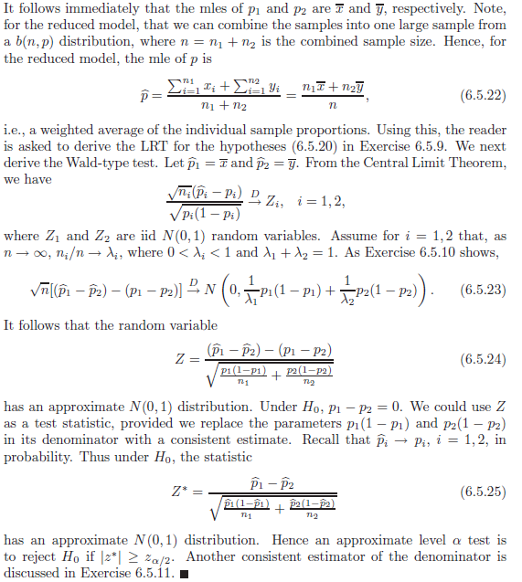

Example 6.6.1 – Non-Codable (Reason: Theoretical example with the purpose of proving a concept) 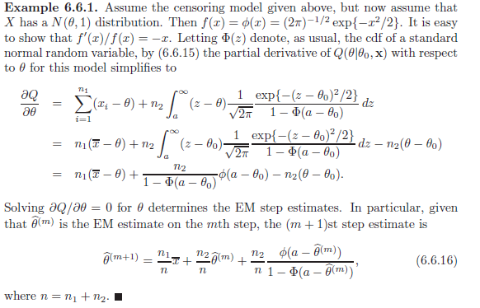

**Chapter 7: Sufficiency**

Example 7.1.1 – Non-Codable (Reason: Theoretical example with the purpose of proving a concept)  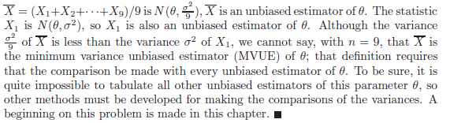

Example 7.1.2 – Non-Codable (Reason: Theoretical example with the purpose of proving a concept) 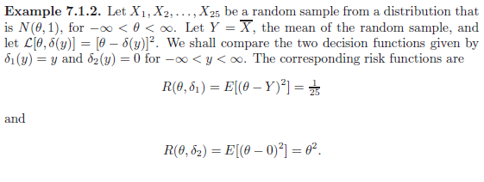 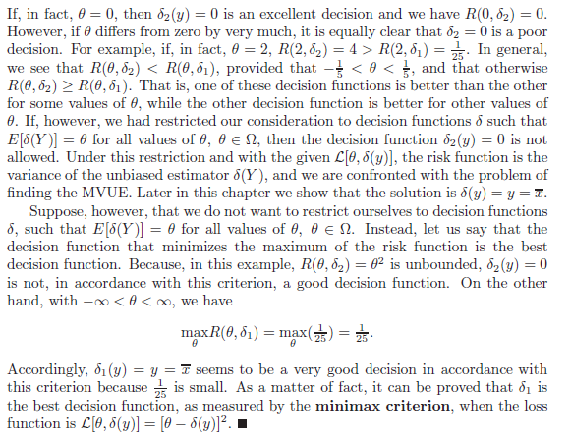

Example 7.2.1 – Non-Codable (Reason: Theoretical example with the purpose of proving a concept) 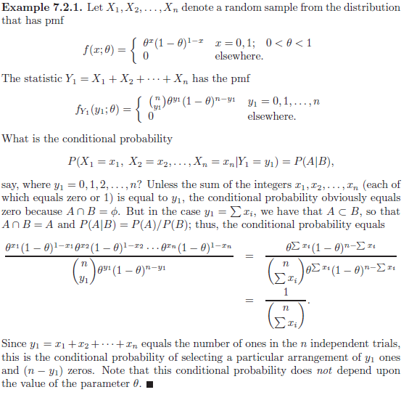

Example 7.2.2 – Non-Codable (Reason: Theoretical example with the purpose of proving a concept) 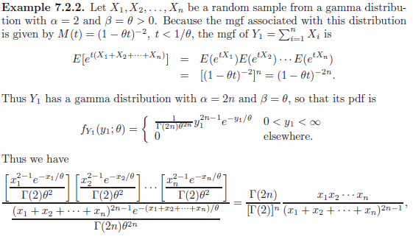 

Example 7.2.3 – Non-Codable (Reason: Theoretical example with the purpose of proving a concept) 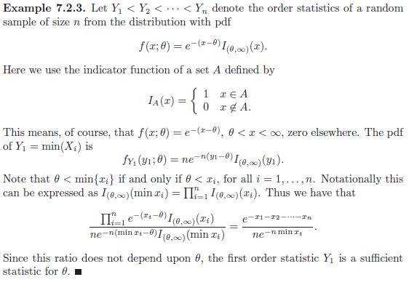

Example 7.2.4 – Non-Codable (Reason: Theoretical example with the purpose of proving a concept) 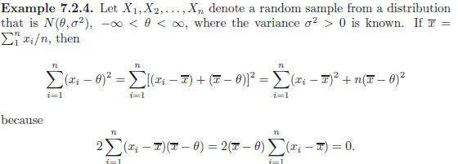 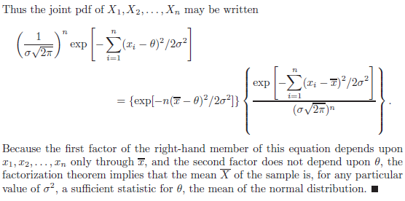

Example 7.2.5 – Non-Codable (Reason: Theoretical example with the purpose of proving a concept) 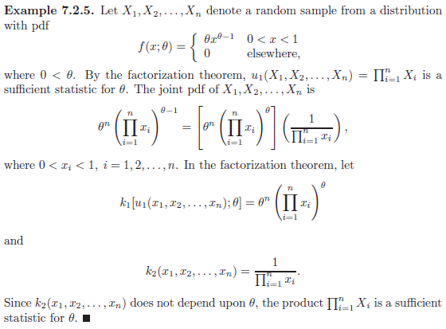

Example 7.2.6 – Non-Codable (Reason: Theoretical example with the purpose of proving a concept) 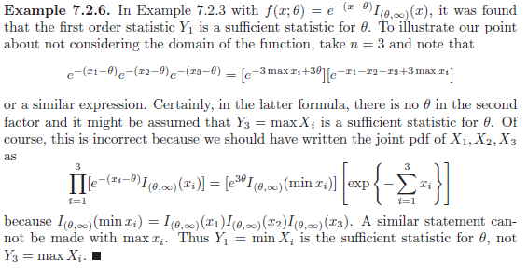

Example 7.3.1 – Non-Codable (Reason: Theoretical example with the purpose of proving a concept) 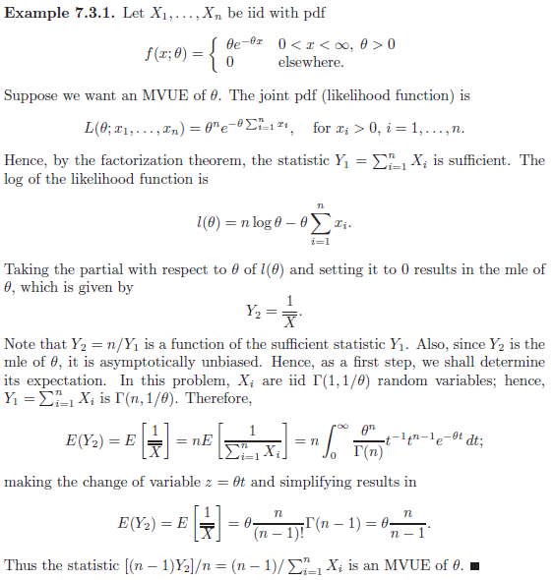

Example 7.3.2 – Non-Codable (Reason: Theoretical example with the purpose of proving a concept) 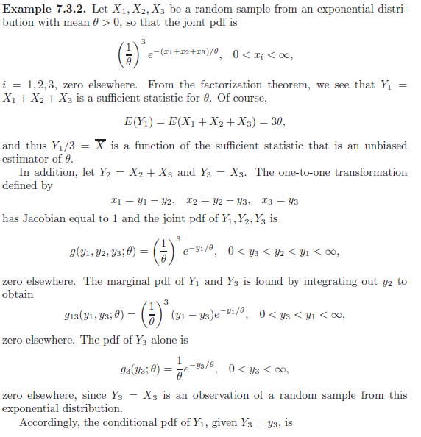 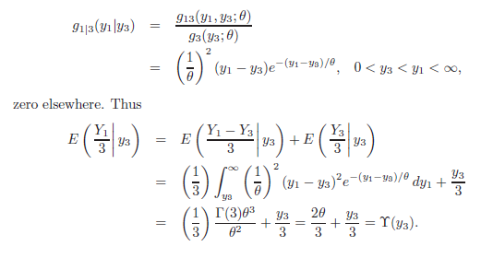 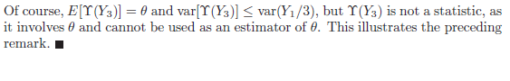

Example 7.4.1 – Non-Codable (Reason: Theoretical example with the purpose of proving a concept) 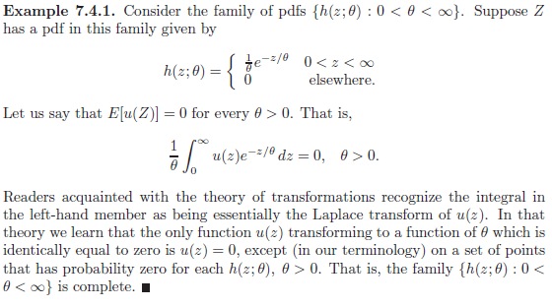

Example 7.4.2 – Non-Codable (Reason: Theoretical example with the purpose of proving a concept) 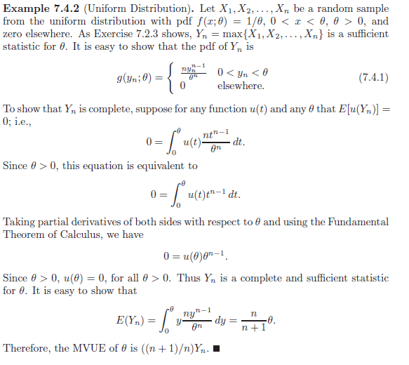

Example 7.5.1 – Non-Codable (Reason: Theoretical example with the purpose of proving a concept) 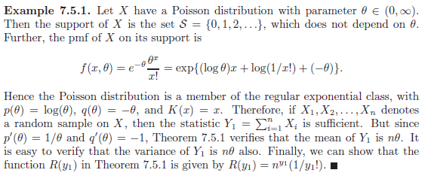

Example 7.5.2 – Non-Codable (Reason: Theoretical example with the purpose of proving a concept) 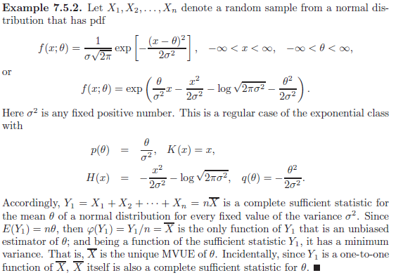

Example 7.5.3 – Non-Codable (Reason: Theoretical example with the purpose of proving a concept) 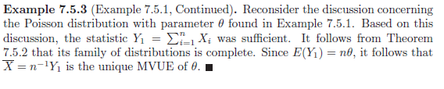

Example 7.6.1 – Non-Codable (Reason: Theoretical example with the purpose of proving a concept) 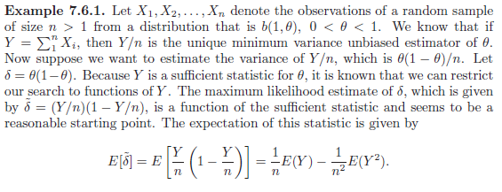 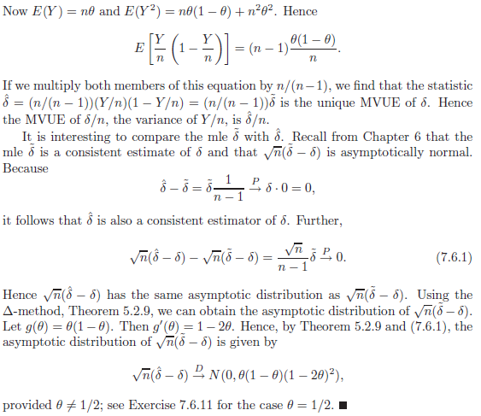

Example 7.6.2 – Non-Codable (Reason: Theoretical example with the purpose of proving a concept) 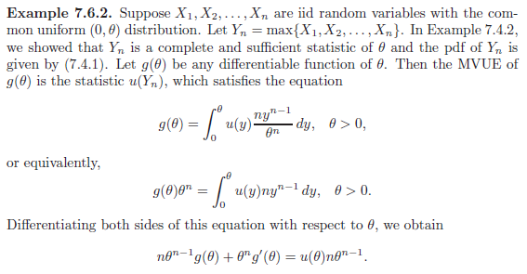 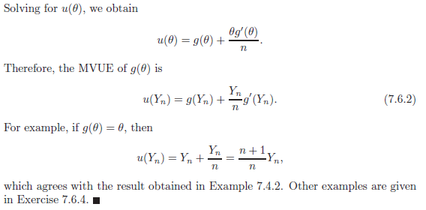

Example 7.6.3 – Non-Codable (Reason: Theoretical example with the purpose of proving a concept) 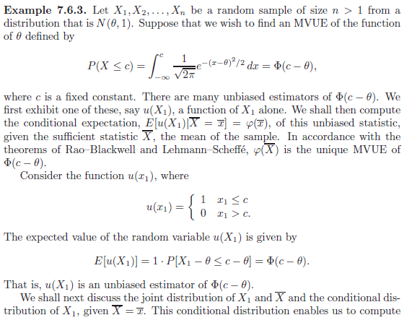 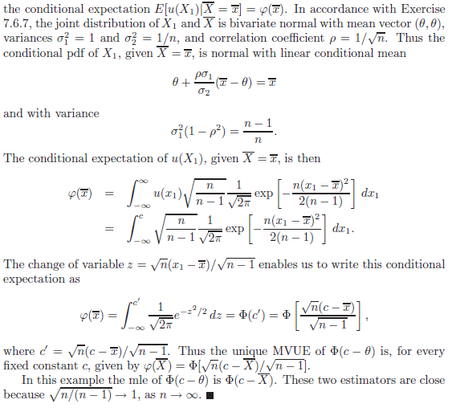

Example 7.7.1 – Non-Codable (Reason: Theoretical example with the purpose of proving a concept) 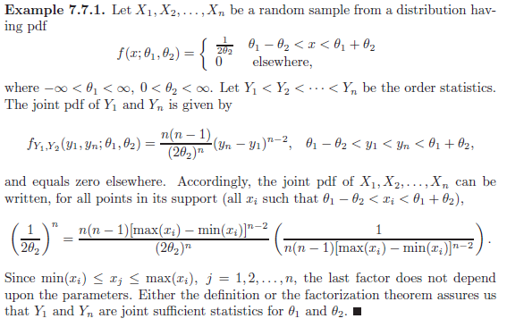

Example 7.7.2 – Non-Codable (Reason: Theoretical example with the purpose of proving a concept) 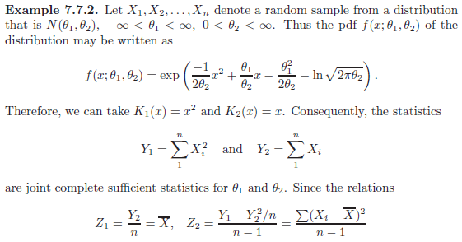 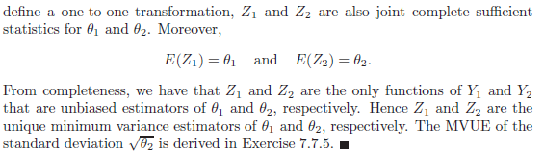

Example 7.7.3 – Non-Codable (Reason: Theoretical example with the purpose of proving a concept) 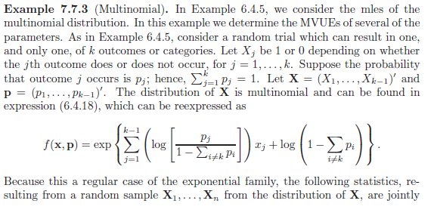 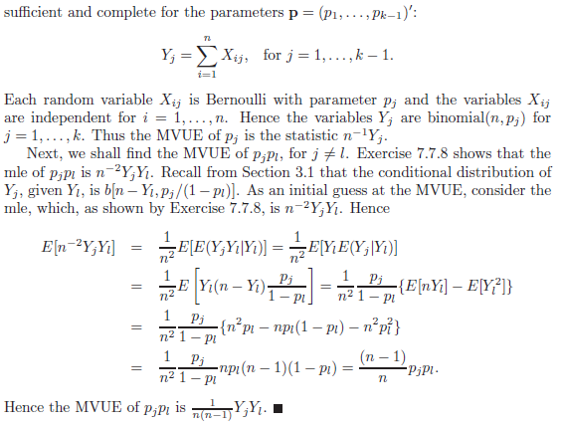

Example 7.7.4 – Non-Codable (Reason: Theoretical example with the purpose of proving a concept) 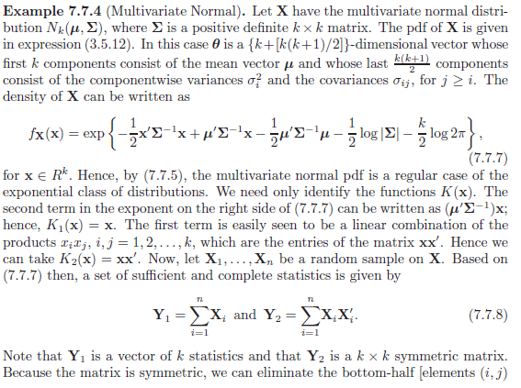 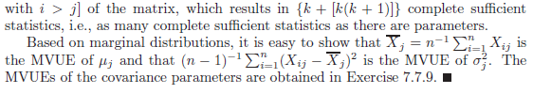

Example 7.7.5 – Non-Codable (Reason: Theoretical example with the purpose of proving a concept) 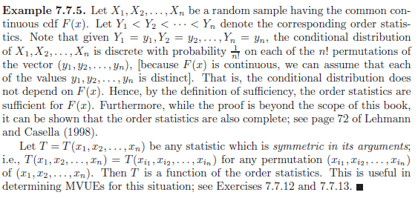

Example 7.8.1 – Non-Codable (Reason: Theoretical example with the purpose of proving a concept) 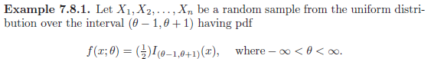 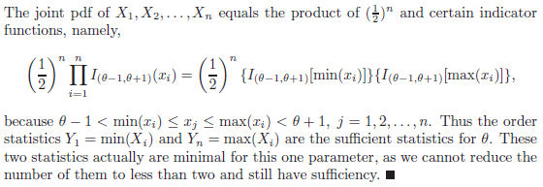

Example 7.8.2 – Non-Codable (Reason: Theoretical example with the purpose of proving a concept) 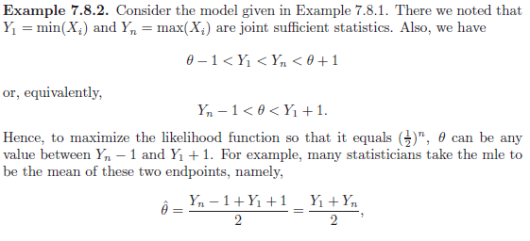 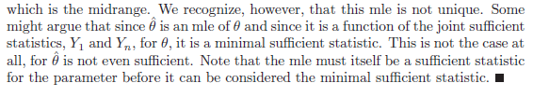

Example 7.8.3 – Non-Codable (Reason: Theoretical example with the purpose of proving a concept) 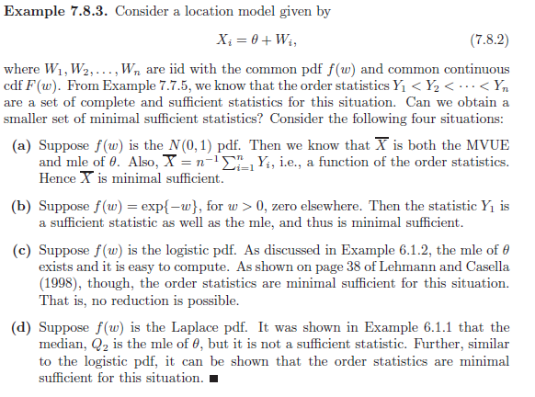

Example 7.8.4 – Non-Codable (Reason: Theoretical example with the purpose of proving a concept) 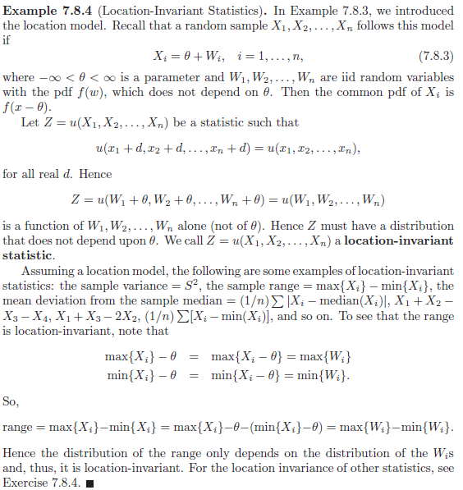

Example 7.8.5 – Non-Codable (Reason: Theoretical example with the purpose of proving a concept) 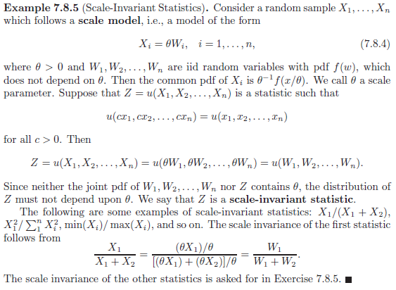

Example 7.8.6 – Non-Codable (Reason: Theoretical example with the purpose of proving a concept) 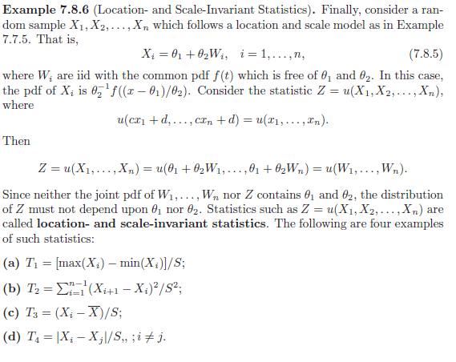 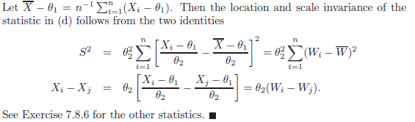

Example 7.9.1 – Non-Codable (Reason: Theoretical example with the purpose of proving a concept) 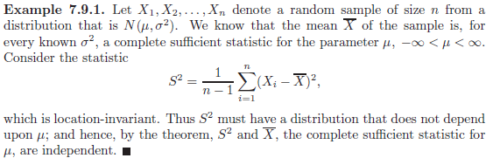

Example 7.9.2 – Non-Codable (Reason: Theoretical example with the purpose of proving a concept) 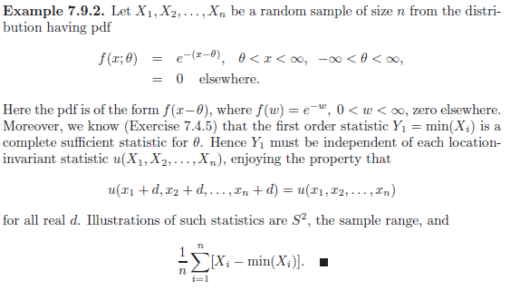

Example 7.9.3 – Non-Codable (Reason: Theoretical example with the purpose of proving a concept) 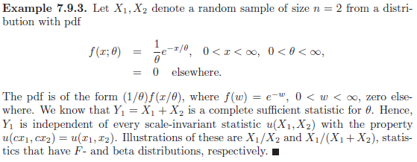

Example 7.9.4 – Non-Codable (Reason: Theoretical example with the purpose of proving a concept)  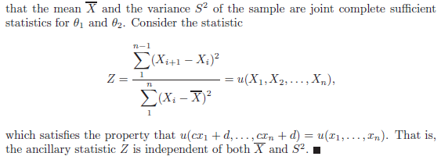

Example 7.9.5 – Non-Codable (Reason: Theoretical example with the purpose of proving a concept) 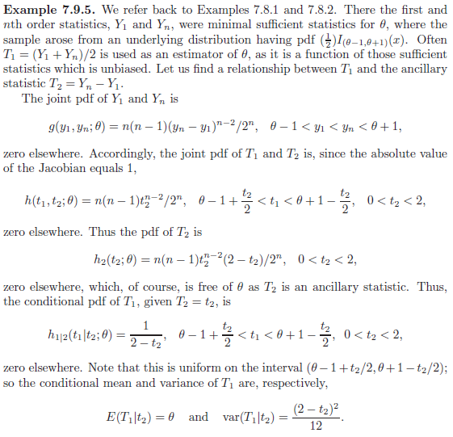 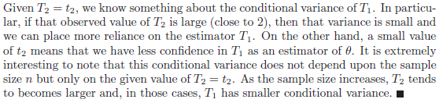

**Chapter 8: Optimal Tests of Hypothesis**

Example 8.1.1 – Codable

Example 8.1.2 – Non-Codable (Reason: Theoretical example with the purpose of proving a concept) 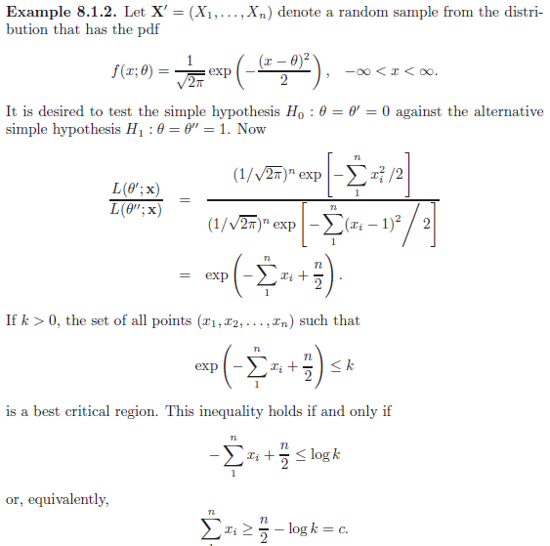 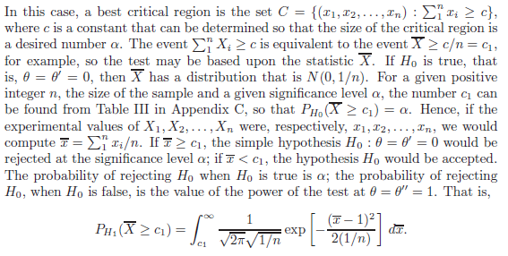 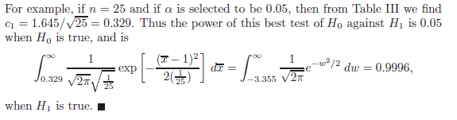

Example 8.1.3 – Codable

Example 8.2.1 – Non-Codable (Reason: Theoretical example with the purpose of proving a concept) 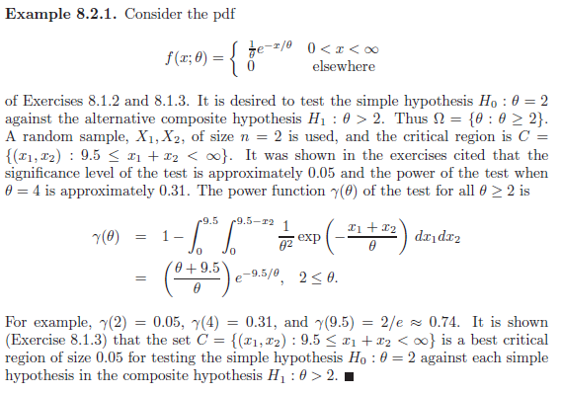

Example 8.2.2 – Non-Codable (Reason: Theoretical example with the purpose of proving a concept) 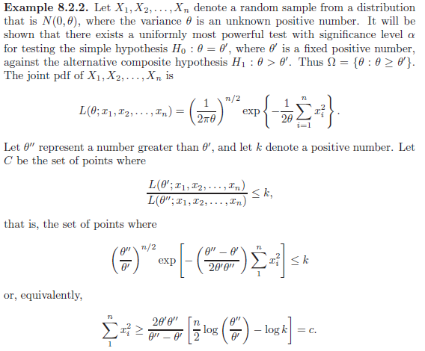 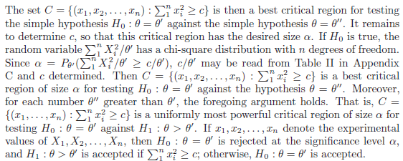

Example 8.2.3 – Non-Codable (Reason: Theoretical example with the purpose of proving a concept) 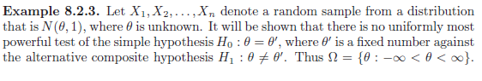 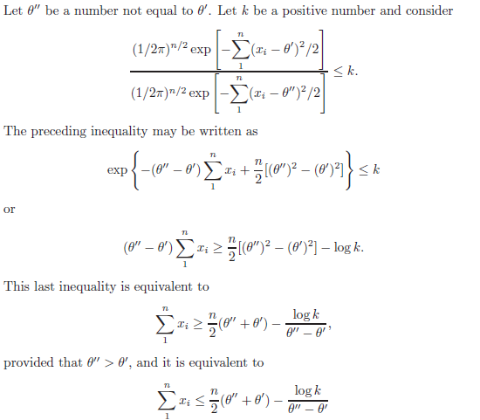 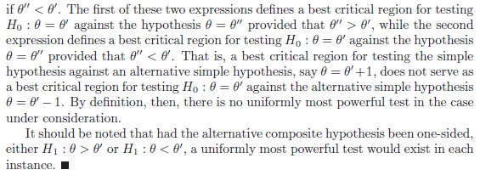

Example 8.2.4 – Non-Codable (Reason: Theoretical example with the purpose of proving a concept) 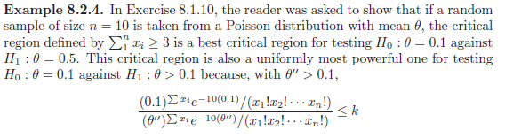 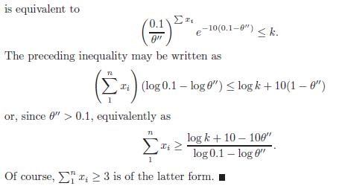

Example 8.2.5 – Non-Codable (Reason: Theoretical example with the purpose of proving a concept) 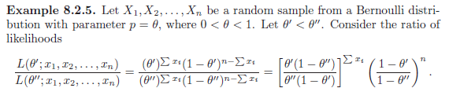 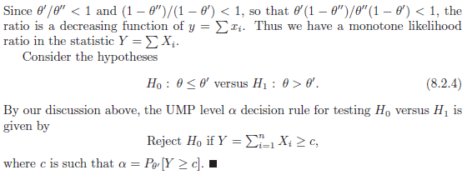

Example 8.3.1 – Non-Codable (Reason: Theoretical example with the purpose of proving a concept) 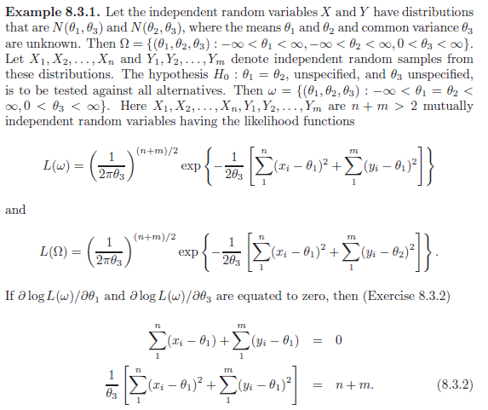 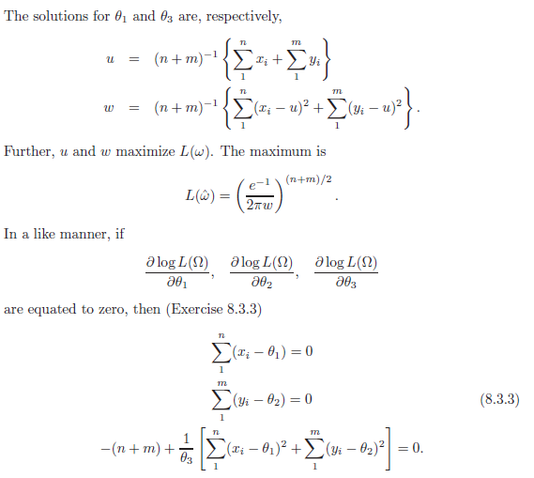 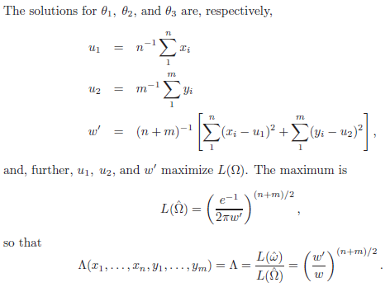 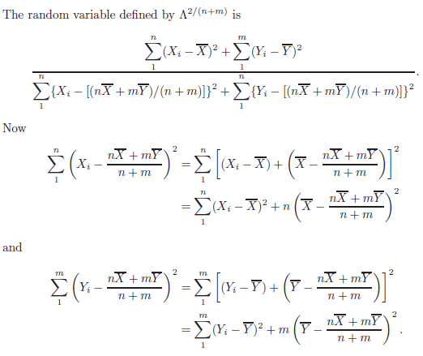 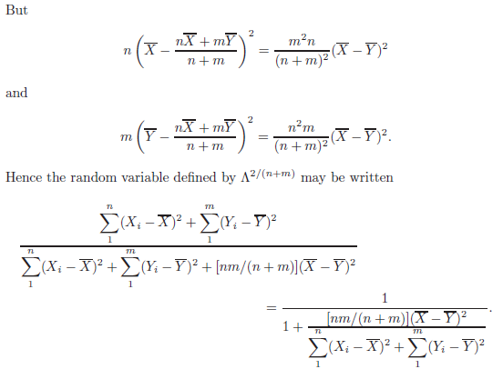 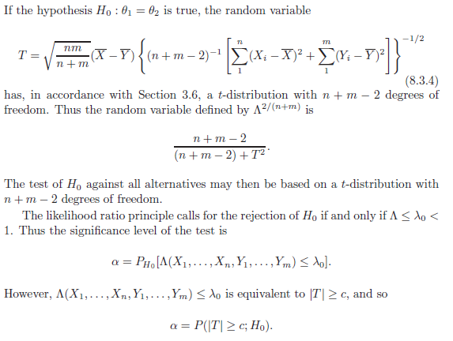

Example 8.3.2 – Non-Codable (Reason: Theoretical example with the purpose of proving a concept) 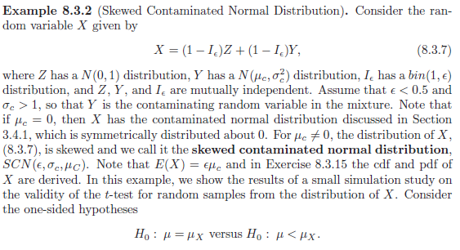 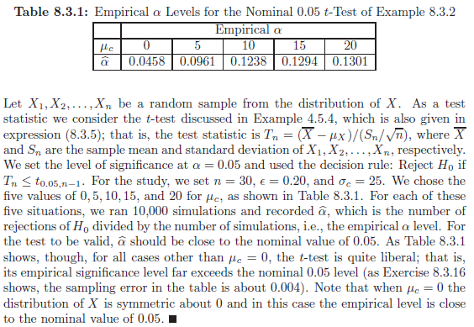

Example 8.3.3 – Non-Codable (Reason: Theoretical example with the purpose of proving a concept) 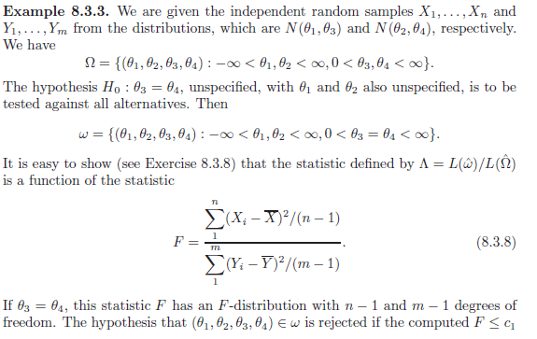 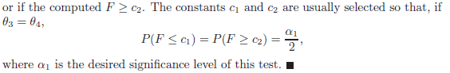

Example 8.3.4 – Non-Codable (Reason: Theoretical example with the purpose of proving a concept) 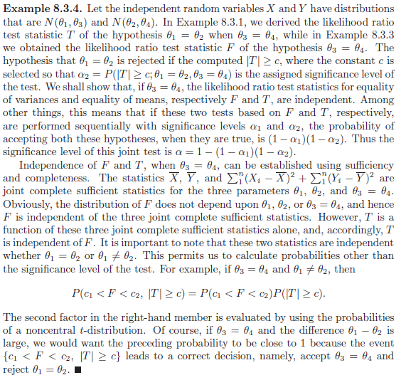

Example 8.4.1 – Non-Codable (Reason: Theoretical example with the purpose of proving a concept) 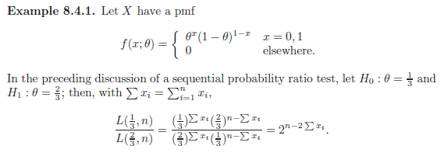 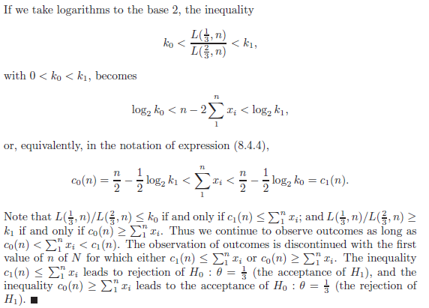

Example 8.4.2 – Non-Codable (Reason: Theoretical example with the purpose of proving a concept) 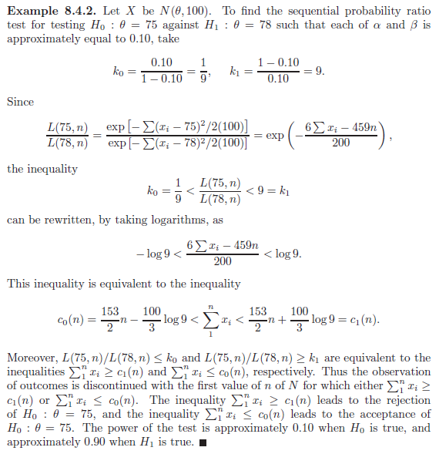

Example 8.5.1 – Non-Codable (Reason: Theoretical example with the purpose of proving a concept) 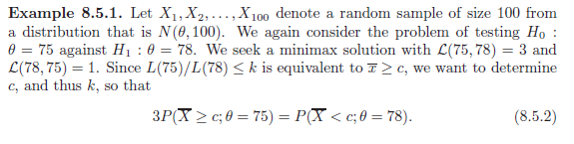 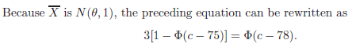

Example 8.5.2 – Non-Codable (Reason: Theoretical example with the purpose of proving a concept) 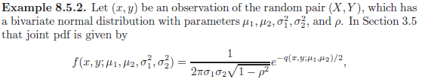 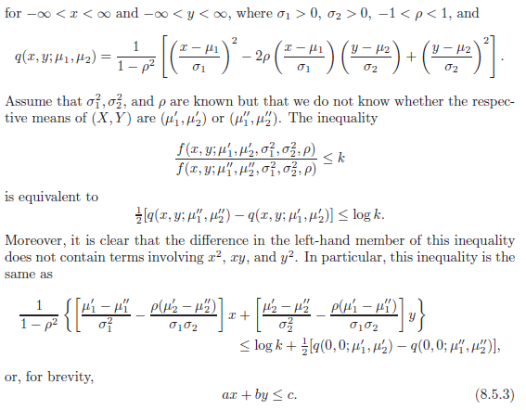

**Chapter 9: Inferences About Normal Models**

Example 9.1.1 – Non-Codable (Reason: Theoretical example with the purpose of proving a concept) 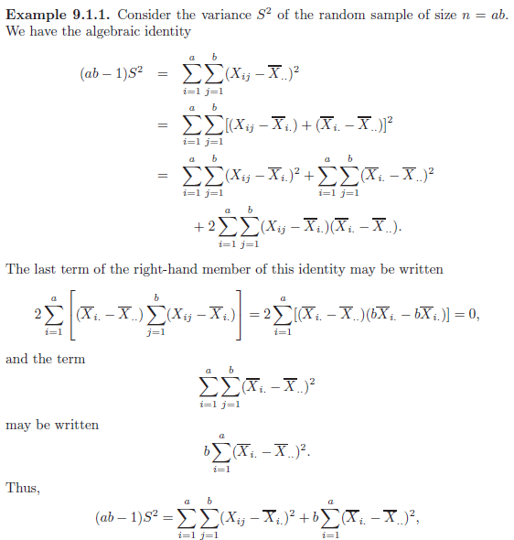 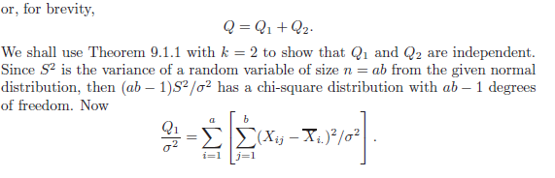 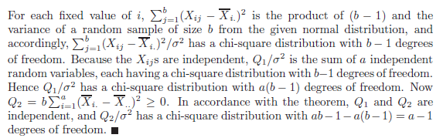

Example 9.1.2 – Non-Codable (Reason: Theoretical example with the purpose of proving a concept) 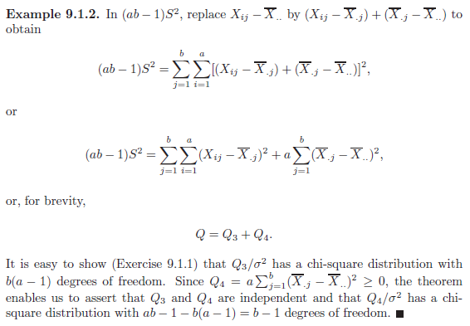

Example 9.1.3 – Non-Codable (Reason: Theoretical example with the purpose of proving a concept) 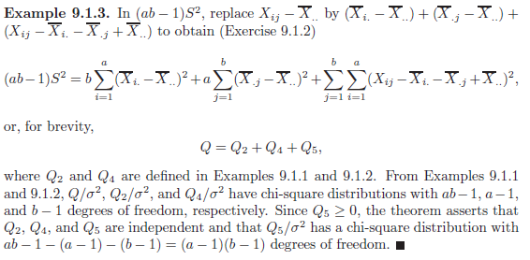

Example 9.6.1 – Non-Codable (Reason: Theoretical example with the purpose of proving a concept) 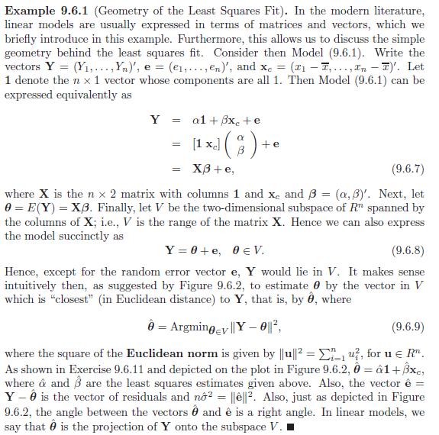

Example 9.8.1 – Non-Codable (Reason: Theoretical example with the purpose of proving a concept) 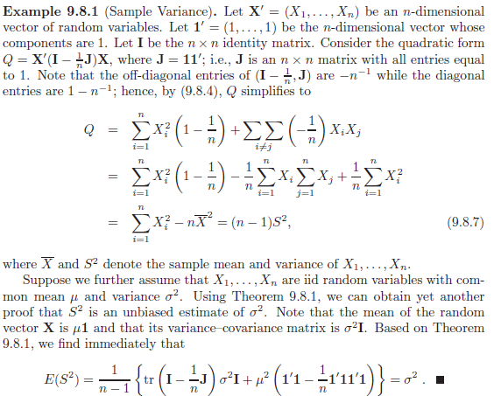

Example 9.8.2 – Non-Codable (Reason: Theoretical example with the purpose of proving a concept) 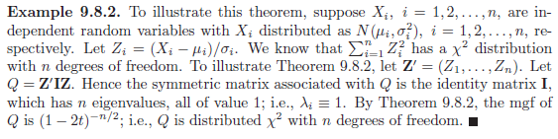

Example 9.8.3 – Non-Codable (Reason: Theoretical example with the purpose of proving a concept) 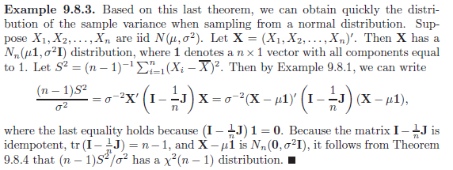

**Chapter 10: Nonparametric and Robust Statistics**

Example 10.1.1 – Non-Codable (Reason: Theoretical example with the purpose of proving a concept) 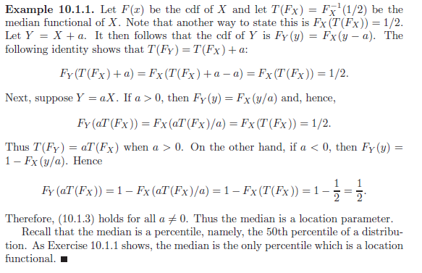

Example 10.1.2 – Non-Codable (Reason: Theoretical example with the purpose of proving a concept) 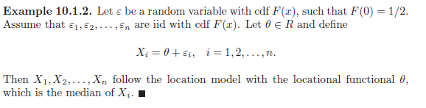

Example 10.2.1 – Non-Codable (Reason: Theoretical example with the purpose of proving a concept) 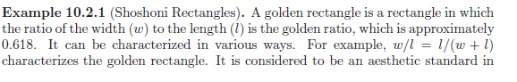 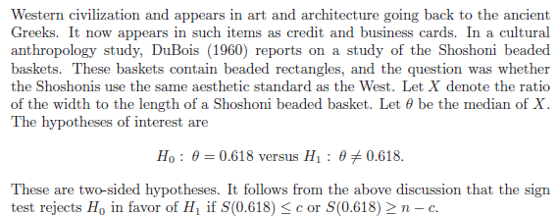

Example 10.2.2 – Non-Codable (Reason: Theoretical example with the purpose of proving a concept) 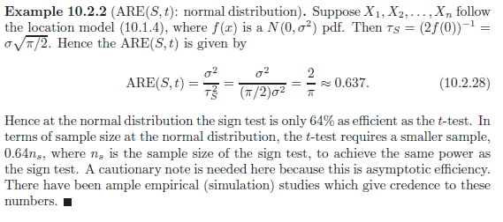

Example 10.2.3 – Non-Codable (Reason: Theoretical example with the purpose of proving a concept) 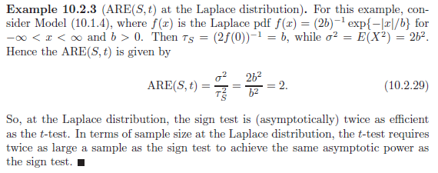

Example 10.2.4 – Non-Codable (Reason: Theoretical example with the purpose of proving a concept) 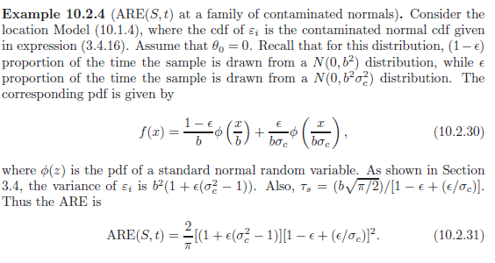

Example 10.2.5 – Non-Codable (Reason: Theoretical example with the purpose of proving a concept) 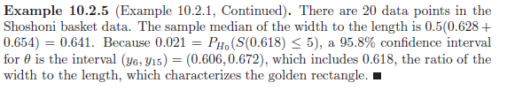

Example 10.3.1 – Codable

Example 10.3.2 – Codable

Example 10.3.3 – Non-Codable (Reason: Theoretical example with the purpose of proving a concept) 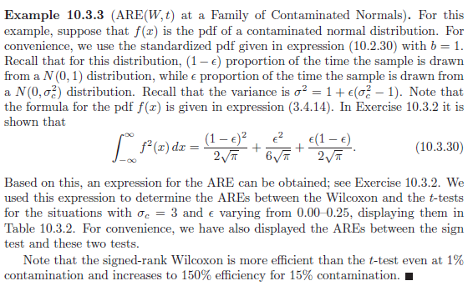

Example 10.3.4 – Non-Codable (Reason: Theoretical example with the purpose of proving a concept) 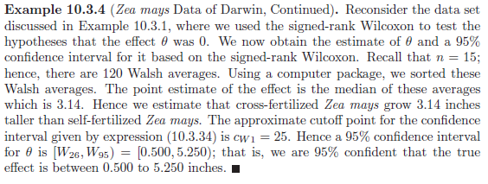

Example 10.4.1 – Non-Codable (Reason: Theoretical example with the purpose of proving a concept) 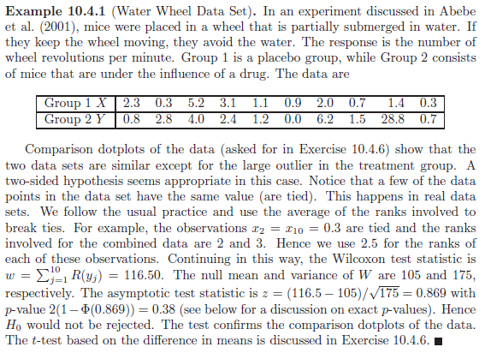

Example 10.4.2 – Non-Codable (Reason: Theoretical example with the purpose of proving a concept) 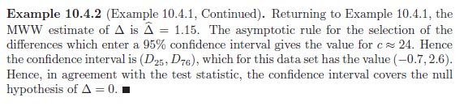

Example 10.5.1 – Non-Codable (Reason: Theoretical example with the purpose of proving a concept) 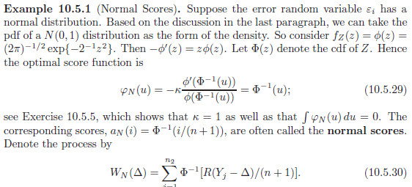 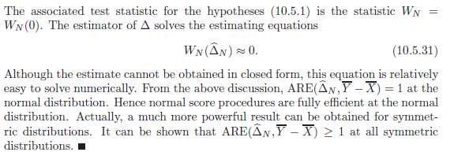

Example 10.5.2 – Non-Codable (Reason: Theoretical example with the purpose of proving a concept) 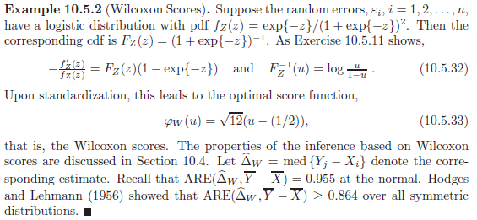

Example 10.5.3 – Non-Codable (Reason: Cannot calculate normal scores and Wilcoxon) 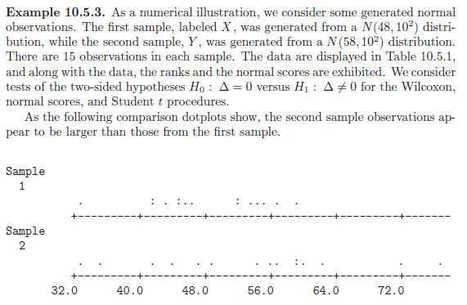 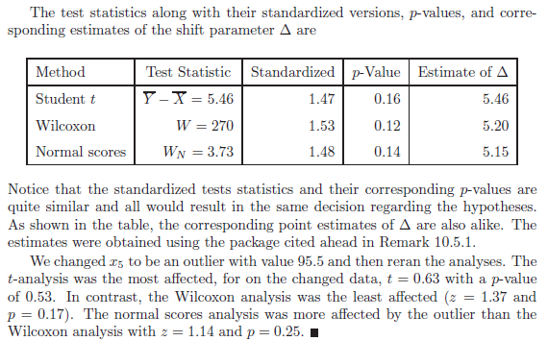

Example 10.5.4 – Non-Codable (Reason: Theoretical example with the purpose of proving a concept) 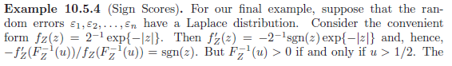 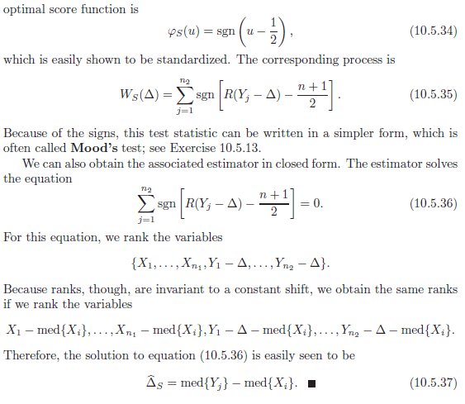

Example 10.6.1 – Non-Codable (Reason: Theoretical example with the purpose of proving a concept) 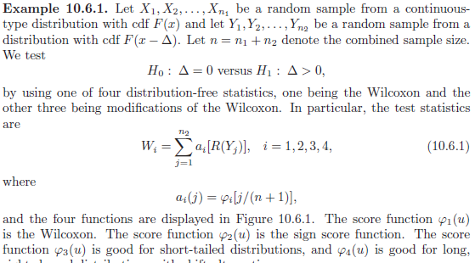 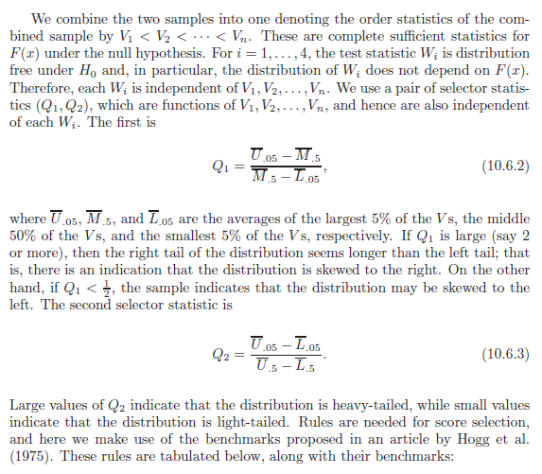 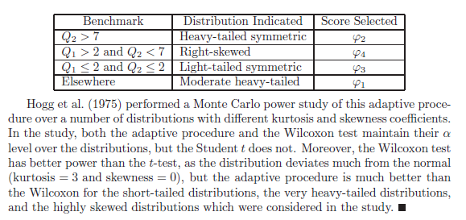

Example 10.7.1 – Non-Codable (Reason: Theoretical example with the purpose of proving a concept) 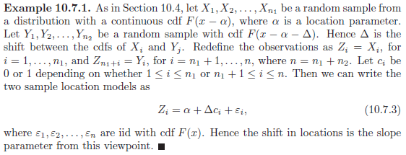

Example 10.7.2 – Codable

Example 10.8.1 – Non-Codable (Reason: Theoretical example with the purpose of proving a concept) 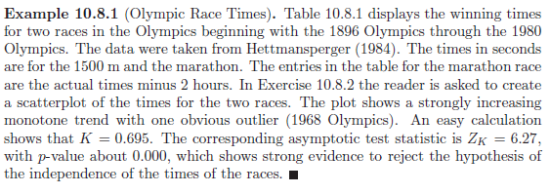

Example 10.8.2 – Non-Codable (Reason: Theoretical example with the purpose of proving a concept) 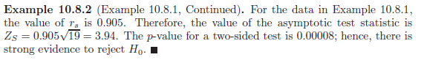

Example 10.9.1 – Non-Codable (Reason: Theoretical example with the purpose of proving a concept) 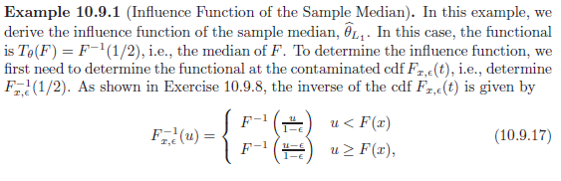 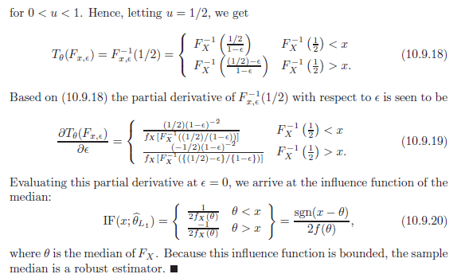

Example 10.9.2 – Non-Codable (Reason: Theoretical example with the purpose of proving a concept) 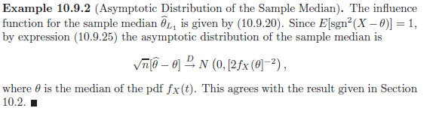

**Chapter 11: Bayesian Statistics**

Example 11.2.1 – Non-Codable (Reason: Theoretical example with the purpose of proving a concept) 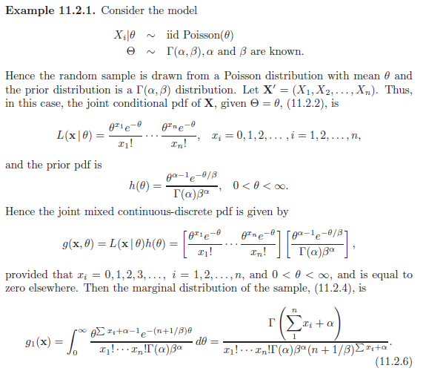 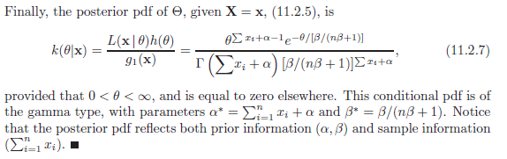

Example 11.2.2 – Non-Codable (Reason: Theoretical example with the purpose of proving a concept) 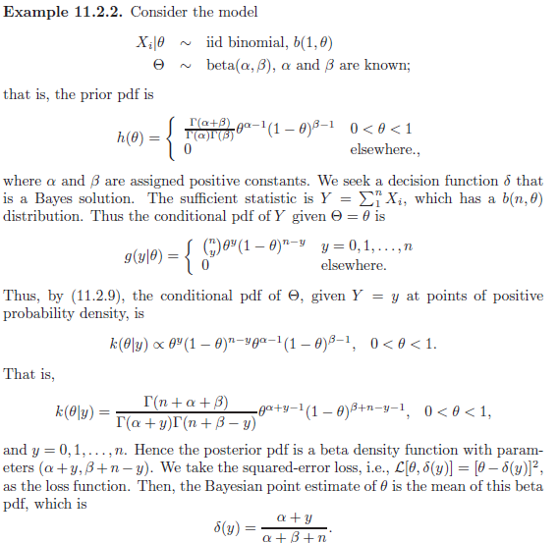 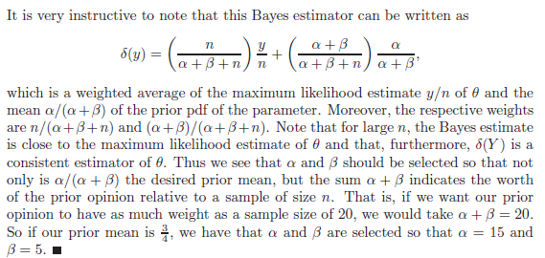

Example 11.2.3 – Non-Codable (Reason: Theoretical example with the purpose of proving a concept) 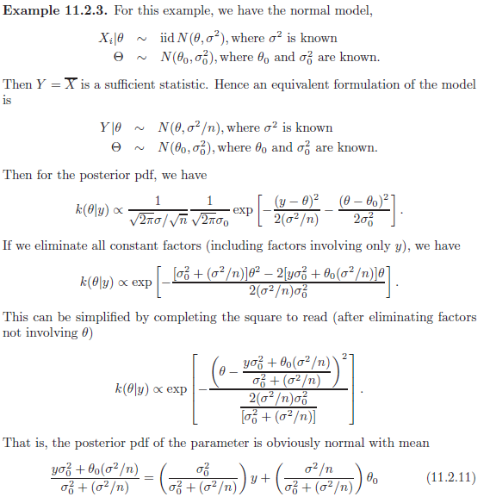 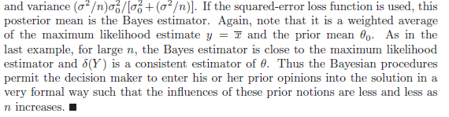

Example 11.2.4 – Non-Codable (Reason: Theoretical example with the purpose of proving a concept) 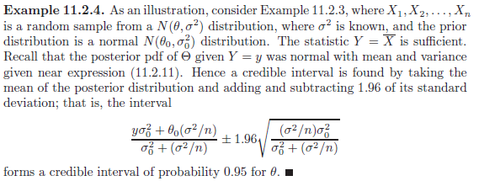

Example 11.2.5 – Non-Codable (Reason: Theoretical example with the purpose of proving a concept) 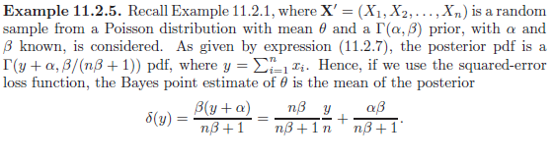 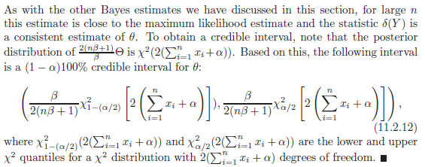

Example 11.2.6 – Non-Codable (Reason: Cannot find interval range) 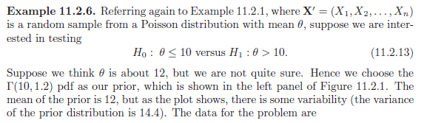 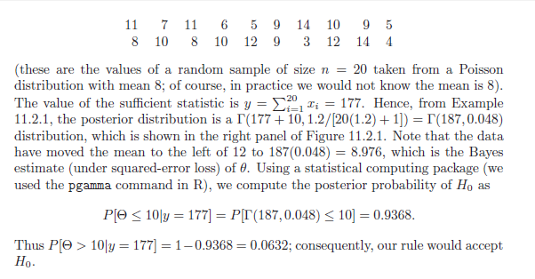 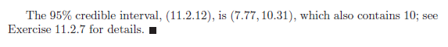

Example 11.3.1 – Non-Codable (Reason: Theoretical example with the purpose of proving a concept) 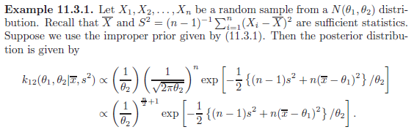 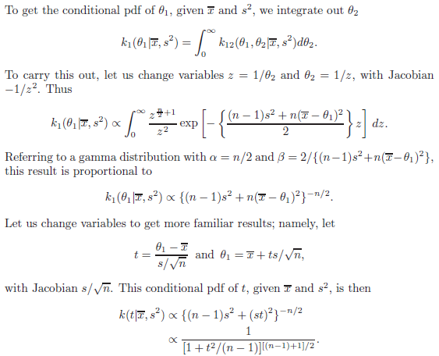 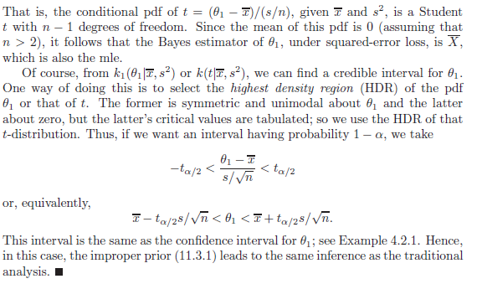

Example 11.3.2 – Non-Codable (Reason: Theoretical example with the purpose of proving a concept) 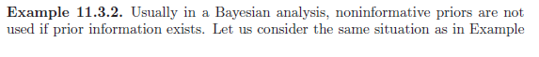 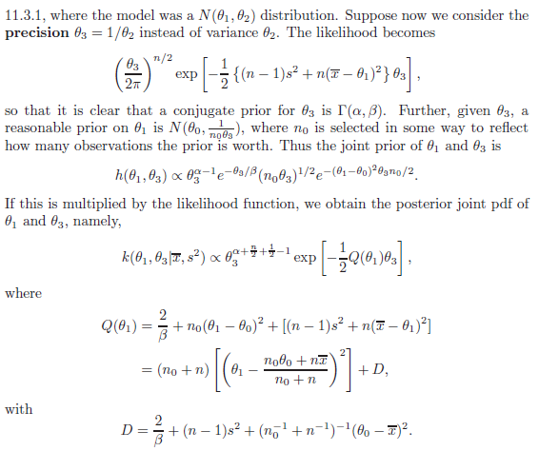 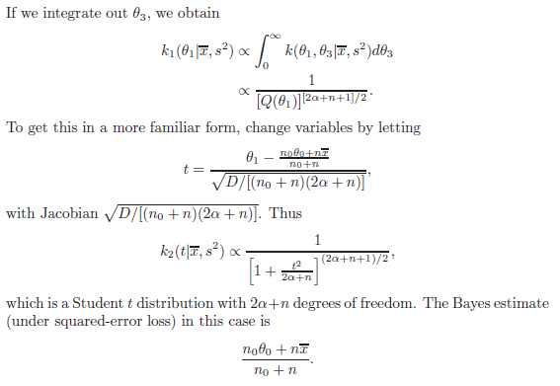 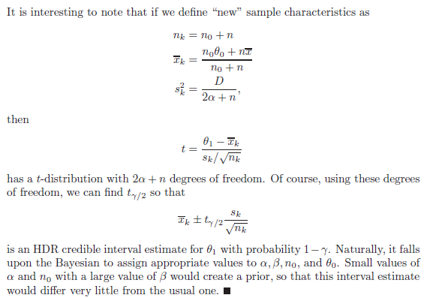

Example 11.4.1 – Non-Codable (Reason: Theoretical example with the purpose of proving a concept) 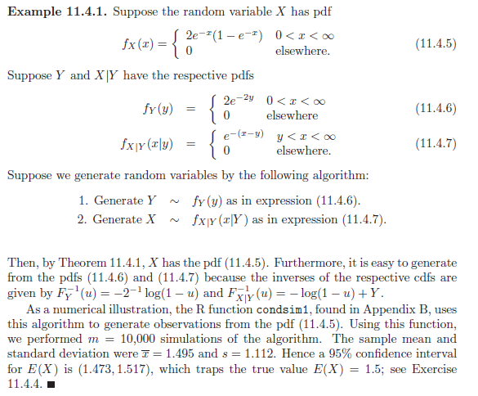

Example 11.4.2 – Non-Codable (Reason: Theoretical example with the purpose of proving a concept) 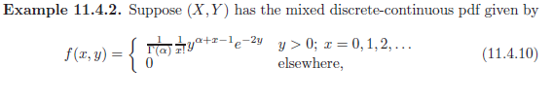 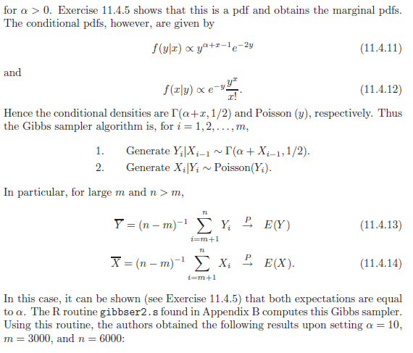 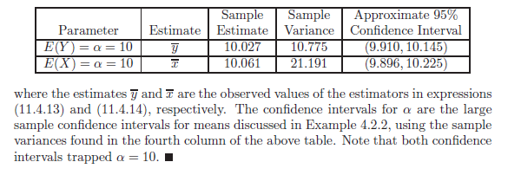

Example 11.5.1 – Non-Codable (Reason: Theoretical example with the purpose of proving a concept) 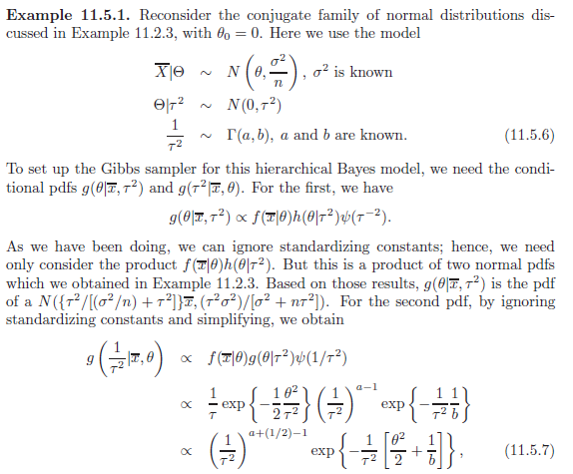 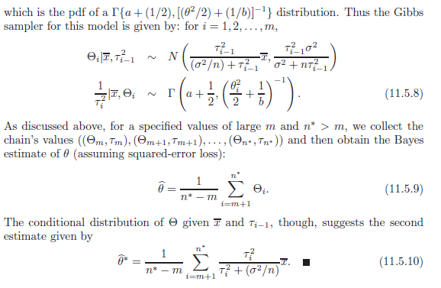

Example 11.5.2 – Non-Codable (Reason: Theoretical example with the purpose of proving a concept) 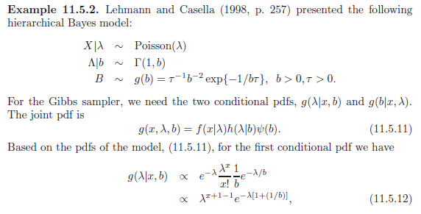 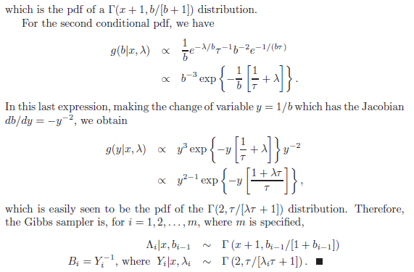

Example 11.5.3 – Non-Codable (Reason: Theoretical example with the purpose of proving a concept) 